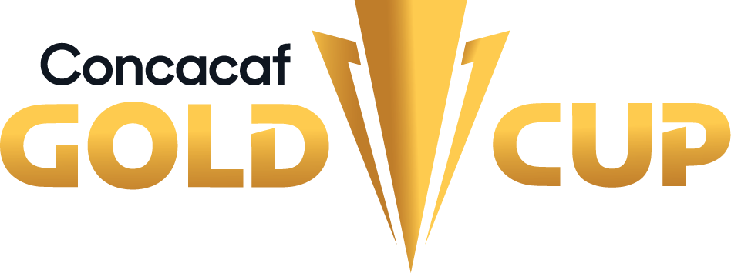

Group C

EL SALVADOR - MARTINIQUE
El Salvador and Martinique will face each other again in the Gold Cup, 20 years since their first encounter at Gillette Stadium on July 16, 2003, in Group C, with a 1-0 victory for El Salvador, courtesy of Marvin González's goal.
El Salvador 1-0 Martinique (Marvin González), Group C - 2003 Gold Cup, Gillette Stadium, Foxborough (July 16, 2003).
PLAYERS WHO HAVE FACED EACH OTHER IN THE GOLD CUP:
SLV: Juan José Gómez, William Torres, Marvin González, Julio Castro, Víctor Velásquez, Alfredo Pacheco, Ramón Sánchez, Santos Cabrera, Guillermo Morán, Juan Campos, Rudis Corrales, Roberto Ochoa, William Alegría, Gilberto Murgas (1 match).
MTQ: Eddy Heurlié, Willy Padoly, Miguel Duragrin, Judes Vaton, David-Alexandre Dicanot, Stéphane Suédile, Charles-Edouard Corindón, Jean-Michel Michaud, Patrick Piercing, Jose Gordon, Jean-Victor Lavril, Gaël Germany, Dominique Reyal (1 match).
COACHES IN THE GOLD CUP:
SLV: Juan Ramón Paredes (SLV) 1 (2003).
MTQ: Theodore Antonin (FRA) 1 (2003).

EL SALVADOR (SLV)
El Salvador's participation in the Gold Cup: 13 (1996, 1998, 2002, 2003, 2007, 2009, 2011, 2013, 2015, 2017, 2019, 2021, and 2023).
El Salvador made their debut in the 1996 edition, and their best performances were in 2002, 2003, 2011, 2013, 2017, and 2021 when they advanced to the quarterfinals.
With 9 goals, Rodolfo Zelaya is the all-time leading scorer in Gold Cup history.
First match in the group stage: El Salvador won their last 2 games, 1-0 against Curaçao (2019) and 2-0 against Guatemala (2021). Overall, they have 5 wins, 3 draws, and 4 losses.
Gold Cup Record: G-39 W-11 D-8 L-20 (GF-35 GA-63).
Top scorers in Gold Cup: Rodolfo Zelaya (9), Nelson Bonilla (3), Joaquín Rivas (3), Osael Romero (3), Raúl Díaz Arce (2).
Top scorers in Gold Cup 2021: Joaquín Rivas (3), Alexander Roldan (1), Jairo Henríquez (1), Walmer Martínez (1).
Players with the most appearances: Darwin Cerén (18), Andrés Flores (14), Rudis Corrales (13), Rodolfo Zelaya (13), Ronald Cerritos (11), Xavier García (11).
Coaches with the most games in the Gold Cup: Carlos de los Cobos MEX (9).
Their best performance was: Quarter finals in Gold Cup 2002, 2003, 2011, 2013, 2017, 2021.
Players used in the Gold Cup: 122.
Saves (by Editions 2015/2017/2019/2021): 41. Top Goalkeepers: Derby Carrillo (20), Mario González (11), Henry Hernández (7).
Penalty Shootout: 1. WIN: 0. LOST: 1 (5-3 vs PAN in QF 2011).
Best Result: 6-1 vs. Cuba (Rodolfo Zelaya x2, William Romero, Lester Blanco, José Álvarez y Eliseo Quintanilla; Jeniel Márquez), Group A - 2011, Soldier Field, Chicago (12-JUN).
Qualification to the 2023 Gold Cup: 2° Place (Group D - League A).
Record in CNL: GP-10 W-6 D-2 L-2 (GS-16 GA-6).
Top scorers in CNL: Juan Carlos Portillo (3), Rodolfo Zelaya (3), Nelson Bonilla (2), Alexander Larín (2), Cristian Gil, Narciso Orellana, Pablo Punyed, Roberto Domínguez y Darwin Cerén (1).
Record in CNL 2022/23: GP-4 W-1 D-2 L-1 (GS-6 GA-5).
Top scorers in CNL 2022/23 (League A): Nelson Bonilla (2), Alexander Larín (2), Cristian Gil (1).
Assists leader in CNL 2022/23 (League A): Enrico Dueñas (1).
Saves CNL 2022/23: (14). Mario González (10), Tomás Romero (4).
TOP PLAYERS
Alexander Larín has made 10 appearances in 4 out of the last 5 editions of the Gold Cup (2013, 2015, 2017, and 2021).
Nelson Bonilla has been present in 9 matches and scored three goals in 3 out of the last 4 editions of the Gold Cup (2015, 2017, and 2019), where he found the back of the net once. He is El Salvador's top scorer in the CNL with 3 goals and has scored 6 goals in the Concacaf World Cup qualifiers.
Joaquín Rivas was the top scorer for El Salvador in the 2021 Gold Cup, with 3 goals in 4 matches, and he was the player with the most shots on target for his team with 10.
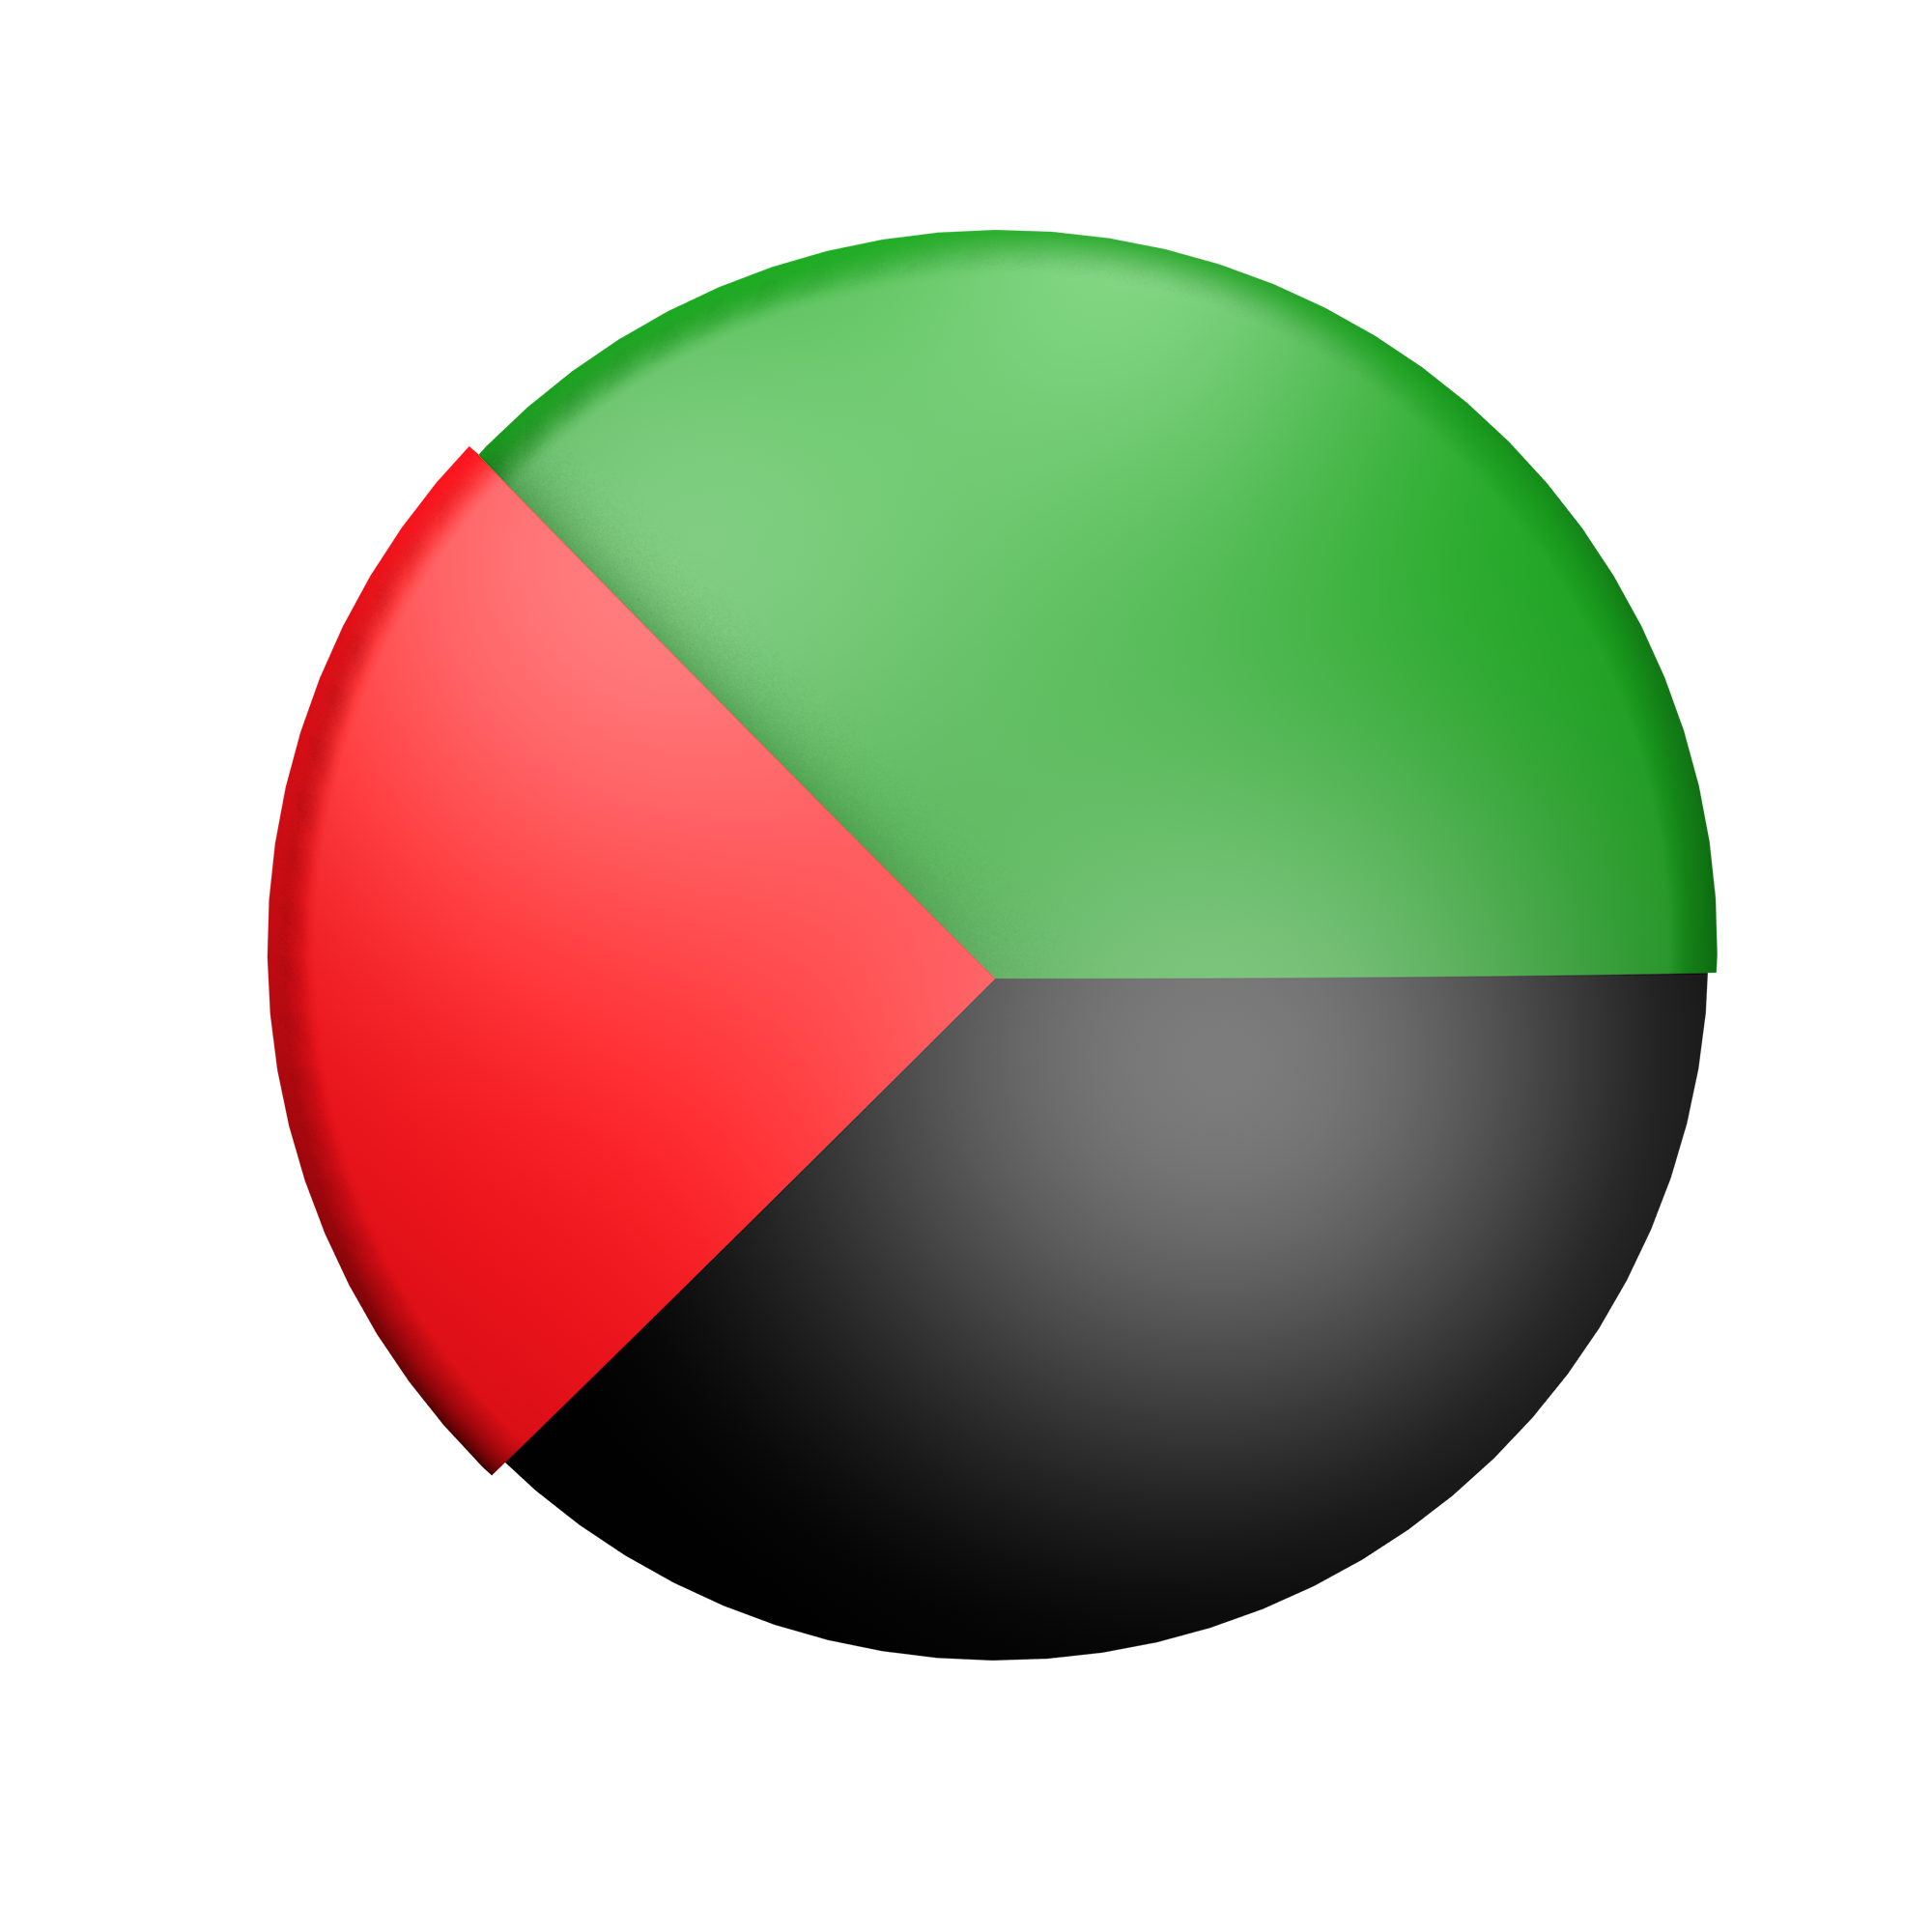MARTINIQUE (MTQ)
Martinique have participated in 8 editions of the Concacaf Gold Cup: 1993, 2002, 2003, 2013, 2017, 2019, 2021, 2023.
Gold Cup Record: G-22 W-6 D-2 L-14 (GF-24 GA-50). *Include Prelims.
DEBUT: 1993 (Group Stage)
Top scorers in Gold Cup: Kevin Parsemain (5), Kevin Fortune (3), Emmanuel Riviere (2), Brighton Labeau (2).
Top scorers in Gold Cup 2021: Emmanuel Riviere (2), Kevin Fortune (1).
Players with the most appearances: Daniel Herelle (14), Stéphane Abaul (10), Kevin Parsemain (9), Jean-Sylvian Babin (9), Sébastien Crétinoir (9), Kevin Fortune (8).
Coaches in the Gold Cup: Mario Bocaly MTQ (6), Theodore Antonin MTQ (5).
Their best performance was: Quarter finals in Gold Cup 2002.
Players used in the Gold Cup: 93.
Penalty Shootout: 1. WIN: 0. LOST: 1 (6-5 vs. Canada in Quarter finals 2002).
Best Result: 3-0 vs. Cuba (Joris Marveaux, Stéphane Abaul y Kevin Fortune), Group A - 2019, in Mile High Stadium, Denver (19-JUN).
Qualification to the 2023 Gold Cup (Group Stage): Preliminary Round Gold Cup 2023: 3-1 vs. Saint Lucia (Round 1), 2-0 vs. Puerto Rico (Round 2).
Top scorers in Preliminary Round 2023: Brighton Labeau (2), Kevin Fortune, Karl Fabien, Patrick Burner.
Assists leader in Preliminary Round 2023: Enrick Reuperne (2), Florent Poulolo, Ronny Labonne, Cyril Mandouki (1).
Saves in Preliminary Round 2023: 4. Yannis Clementia (4).
Record in CNL: GP-8 W-0 D-4 L-4 (GS-5 GA-14).
Top scorers in CNL: Mickael Biron (1), Cyril Mandouki (1), Emmanuel Riviere (1), Jordy Delem (1).
Record in CNL 2022/23: GP-4 W-0 D-1 L-3 (GS-1 GA-9).
Top scorers in CNL 2022/23 (League A): Mickael Biron (1).
Assists leader in CNL 2022/23 (League A): Cyril Mandouki (1).
Saves CNL 2022/23: (16). Yannis Clementia (15), Yannick Etile (1).

TOP PLAYERS:
Brighton Labeau: He was a decisive player in the Preliminaries, scoring two goals against Saint Lucia and Puerto Rico, and was the leader in shots with 7.
Enrick Reuperne: He was the leader in assists in the Preliminaries with (2) and took 3 shots in the 51 minutes played. In the 2021 edition, he played 64 minutes in 3 appearances.
Florent Poulolo: He provided an assist in the Preliminaries and was the player with the highest passing accuracy (98%) out of 192 attempted passes on the field.

