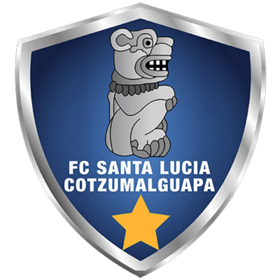 | SANTA LUCIA V. |  | KNOCKOUT STAGES |  | DEPORTIVO  SAPRISSA | 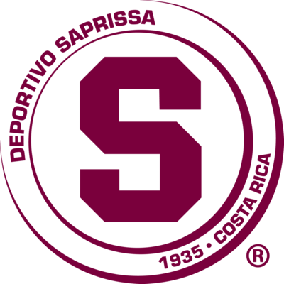

 | SEPTEMBER 23 |  | 8 PM ET |  | Doroteo Guamuch Flores Stadium

DATA

SANTA LUCIA vs. DEP. SAPRISSA
They will meet for the first time in the Scotiabank Concacaf League.
It will be the 10th match of the SCL at the Estadio Nacional Mateo Flores. Comunicaciones, Antigua, Guastatoya and Santa Lucía Cotzumalguapa played at home in this stadium.
Santa Lucía will play its second match in this stadium: it defeated Metropolitan (PUR) 3-0 in the 2021 Preliminary Round (Isaac Acuña, Juan David Osorio and Brandon de León).
It will be the second game between a team from Guatemala and one from Costa Rica in the SCL, Deportivo Saprissa beat Municipal 4-1 (Johan Venegas x4; Ramiro Rocca) single match of R16 2020, Ricardo Saprissa Aymá Stadium.
SANTA LUCIA V. (GUA)
FOUNDATION: 1992.
COACH: Mario Acevedo (NCA).
PARTICIPATIONS: 1 (2021).
RECORD: GP-2 W-2 T-0 L-0 (GF-5 GA-1).
He eliminated Metropolitan of Puerto Rico in the Preliminary Round (3-0, 1-2).
SCORERS: Isaac Acuña (USA) with 2, Juan David Osorio (COL), Brandon de León (GUA) and Víctor Guay (GUA) with 1 c/u.
ASSISTS: Marlon Sequen (GUA), Isaac Acuña (USA) and Diego Ruíz (GUA) with 1.
SAVES IN THE SCL 2021: (0). GOALKEEPERS: Luis Morán (GUA) played both games against Metropolitan without making saves.
DEFINITIONS BY PENALTIES: no.
TOP PLAYERS:
- Isaac Acuña (USA): He has scored two goals in the SCCL 2021 and has an assist, in addition to five shots against Metropolitan of Puerto Rico.
- Marlon Sequén (GUA). He has two assists (2) alongside Canadian Tristan Borges of Forge FC.
DEP. SAPRISSA (CRC)
FOUNDED: 1935.
HEAD COACH: Wilber Weight (CRC).
PARTICIPATIONS: 3 (2019, 2020 and 2021).
BEST RESULT: Champion in 2019.
RECORD: GP-14 W-10 T-1 L-3 (GF-30 GA-12).
TOP SCORERS: Johan Venegas (CRC) 13 goals (He is the top scorer in the history of the SCL), Manfred Ugalde (CRC) 4, Marvin Angulo (CRC) and Christian Bolaños (CRC) with 3.
ASSISTS: Marvin Angulo (CRC) 4, Randall Leall, Michael Barrantes, Johan Venegas 3, Christian Bolaños with 2.
SAVES: (17). GOALKEEPERS: Aaron Cruz (CRC) with 17.
DEFINITIONS BY PENALTIES: no.
THIS IS HOW HE QUALIFIED TO THE SCL 2021: Champion of the Clausura 2021 Tournament of the First Division of Costa Rica. He qualified directly to the 2021 SCL Knockout Stages.
TOP PLAYERS:
- Marvin Angulo (CRC). Champion in 2019 and Runner up in 2020 with Deportivo Sapriss. He was elected to the Ideal XI in 2019 after scoring two goals in 7 matches. He scored the last goal in the final against LD Alajuelense in 2019.
- Michael Barrantes (CRC). He is one of the players with the most wins in the SCCL (9). Champion in 2019 and Runner-up in 2020 with Deportivo Saprissa, where he contributed three assists and was the player with the most shots (12).

