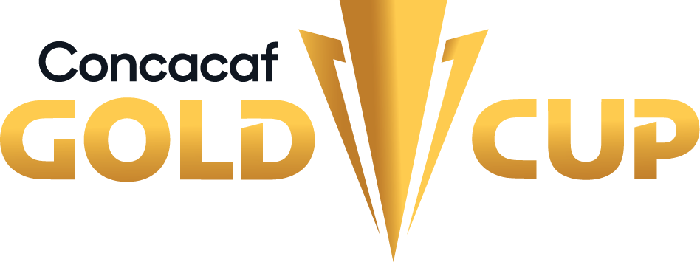

Trinidad Tobago - Saint Kitts and Nevis

Trinidad leads the all-time series in regulation time GP-13 W-12 D-0 L-1 (GF-36 GA-11).
It will be the first time they square-off in the Concacaf Gold Cup
HEA-TO-HEAD:
DATE | VENUE | TEAM A | TEAM B |  | COMPETITION
1993-05-30 | Independence Park, Kingston | Trinidad | St Kitts & Nevis | 3-2 | Shell Caribbean Cup 1993
1996-05-28 | Port of Spain | Trinidad | St Kitts & Nevis | 5-1 | Shell Caribbean Cup 1996
1997-07-08 | Warner Park, Basseterre | St Kitts & Nevis | Trinidad | 0-3 | Shell Caribbean Cup 1997
1997-07-13 | Port of Spain | Trinidad | St Kitts & Nevis | 4-0 | Shell Caribbean Cup 1997
2002-07-28 | Warner Park, Basseterre | St Kitts & Nevis | Trinidad | 2-1 | Friendly 2002
2002-11-15 | Hasely Crawford Stadium, Port of Spain | Trinidad | St Kitts & Nevis | 2-0 | Qualifiers 2003 Gold Cup
2003-08-02 | Warner Park, Basseterre | St Kitts & Nevis | Trinidad | 1-2 | Friendly 2003
2004-09-04 | Warner Park, Basseterre | St Kitts & Nevis | Trinidad | 1-2 | Qualifiers 2006 FIFA WC
2004-10-10 | Manny Ramjohn Stadium, Marabella | Trinidad | St Kitts & Nevis | 5-1 | Qualifiers 2006 FIFA WC
2008-11-07 | Marvin Lee Stadium, Macoya | Trinidad | St Kitts & Nevis | 3-1 | Qualifiers 2009 Gold Cup
2009-07-12 | Warner Park, Basseterre | St Kitts & Nevis | Trinidad | 2-3 | Friendly 2009
2012-10-12 | Warner Park, Basseterre | St Kitts & Nevis | Trinidad | 0-1 | Qualifiers 2013 Gold Cup
2021-06-08 | Estadio Olímpico, Santo Domingo | Trinidad | St Kitts & Nevis | 2-0 | Concacaf Qualifiers 2022 FIFA WC

TRINIDAD (TRI)
Trinidad have participated in 12 editions of the Concacaf Gold Cup: 1991, 1996, 1998, 2000, 2002, 2005, 2007, 2013, 2015, 2019, 2021, 2023.
Kenwyne Jones, Kevin Molino, and Arnold Dwarika are the top scorers in the Gold Cup with 4 goals each.
In each edition of the Gold Cup, Trinidad and Tobago won their first match twice out of eleven. They defeated Honduras 3-1 in 1998 and Guatemala 3-1 in 2015. Their overall record includes 2 victories, 4 draws, and 5 losses.
Team Record: GP-35 W-8 D-11 L-16 (GS-47 GA-60) / 33% effectiveness.
Top scorers in Gold Cup: Arnold Dwarika (4), Kevin Molino (4), Kenwyne Jones (4), Stern John (3), Russell Latapy (3).
Top scorers in Gold Cup 2021: Reon Moore (3), Kevin Molino (2), Judah García (1), Marcus Joseph (1), Ryan Telfer (1).
Players with the most appearances: Aubrey David (13), Marvin Andrews (11), Khaleem Hyland (10), Angus Eve (10), Joevin Jones (10), Kevin Molino (10), Kenwyne Jones (10 PJ).
Coaches in the Gold Cup: Stephen Hart CAN (8) y Bertille St Clair TRI (6).
Their best performance: 3° Place in Gold Cup 2000.
Players used in the Gold Cup: 124.
Penalty Shootout Decisions: 2. WIN: 1. LOST: 1. Won: Trinidad 1-1 (8-7) French Guiana (Kevin Molino; Arnold Abelinti), Second Round - Prelims Gold Cup 2021, DRV PNK Stadium, Fort Lauderdale (6-JUL-2021). Lost: Trinidad 1-1 (5-6) Panama (Kenwyne Jones; Luis Tejada), QF - Gold Cup 2015, MetLife Stadium (19-JUL-2015).
Best Result/ Best Finish: 6-1 vs. Montserrat (Kevin Molino, Marcus Joseph, Ryan Telfer, Judah García y Reon Dale x2; Lyle Taylor), First Round - Prelims Gold Cup 2021, DRV PNK Stadium, Fort Lauderdale (2-JUL-2021).
Qualification to the 2023 Gold Cup: 2° Place (Group C - League B).
Record in CNL: GP-10 W-4 D-3 L-3 (GS-15 GA-12).
Top scorers in CNL: Joevin Jones (3), Neveal Hackshaw (2), Noah Powder (2), Ryan Telfer (2), Levi García (1), Kevin Molino (1), Judah García (1), John-Paul Rochford (1).
Record in CNL 2022/23: GP-6 W-4 D-1 L-1 (GS-12 GA-4).
Top scorers in CNL 2022/23 (League B): Joevin Jones (2), Neveal Hackshaw (2), Noah Powder (2).
Assists leader in CNL 2022/23 (League B): Levi García (2), Aubrey David (1), Ryan Telfer (1), Alvin Jones (1), Shannon Gómez (1).
Saves CNL 2022/23: (14). Marvin Phillip (10), Nicklas Frenderup (4).

TOP PLAYERS
Kevin Molino: He has played 10 matches in 3 editions of the Gold Cup and scored 4 goals (2013, 2019, and 2021) (including 2 matches and 2 goals in the 2021 Prelims). In the latest edition, he equaled the record of Kenwyne Jones and Arnold Dwarika as Trinidad & Tobago's top scorer in the Gold Cup (4 goals). He scored 2 goals and provided 1 assist in the 2021 Gold Cup Prelims against Montserrat and French Guiana, and he was the player with the most shots (5).
Joevin Jones: He is Trinidad's top scorer in the Concacaf Nations League with 3 goals. He scored 2 goals in the 2022/23 edition (against Nicaragua and the Bahamas). He has played in 10 matches and scored 1 goal (against Guatemala in 2015) in the Gold Cup. He participated in the 2013, 2015, and 2019 editions.
Reon Moore: He scored the only goal for Trinidad and Tobago in the final group stage match of the Gold Cup, a 1-1 draw against Guatemala, in the Group A at the Toyota Stadium.
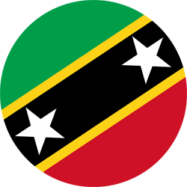SAINT KITTS AND NEVIS (SKN)
CONCACAF GOLD CUP APPEARANCES: Debut
Team Record: GP-2 W-0 D-2 L-0 (GF-2 GA-2). *Include Prelims.
DEBUT: 2023 (Preliminary Round)
Qualification to the 2023 Gold Cup (Group Stage): Preliminary Round Gold Cup 2023: 1-1 (3-2) Curazao vs. (Round 1), 1-1 (4-2) vs. French Guiana (Round 2).
Top scorers in Preliminary Round 2023: Tiquanny Williams (1), Tyquan Terrell (1).
Assists leader in Preliminary Round 2023: Tiquanny Williams (1).
Saves in Preliminary Round 2023: 5. Julani Archibald (5).
Players used in the Prelims for the Gold Cup: 17.
Players with the most appearances: Julani Archibald, Carlos Bertie, Andre Burley, Raheem Hanley, Jacob Hazel, Mervin Lewis, Yohannes Mitchum, Malique Roberts, Romaine Sawyers, Raheem Somersall, Omari Sterling-James, Tiquanny Williams, Gerard Williams, Tyquan Terrell (2 games).
Coaches in the Gold Cup: Austin Huggins SKN (2).
Penalty Shootout: 2. WIN: 2. LOST: 0. 1-1 (3-2) vs. Curazao (First Round - Prelims Gold Cup 2023); 1-1 (4-2) vs. French Guiana (Second Round - Prelims Gold Cup 2023).
Prelims Results: 1-1 (2-3) vs. Curazao (Tyquan Terrell; Jürgen Locadia), First Round - Prelims (16-JUN); 1-1 (4-2) vs. French Guiana (Tiquanny Williams; Arnold Abelinti), (20-JUN).
Record in CNL: GP-10 W-4 D-3 L-3 (GS-17 GA-12).
Top scorers in CNL: Román Liburd (4), Omari Sterling-James (2), Keithroy Freeman (2), Kalonji Clarke, Carlos Beritie, Vinceroy Nelson, Tiquanny Williams, Romaine Sawyers, Harrison Panayiotou, Gvaune Rakeem Amory, Tahir Hanley, Tyquan Travis (1).
Record in CNL 2022/23: GP-4 W-3 D-1 L-0 (GS-9 GA-4).
Top scorers in CNL 2022/23 (League C): Keithroy Freeman (2), Omari Sterling-James (1), Kalonji Clarke, Carlos Beritie, Vinceroy Nelson, Tiquanny Williams, Romaine Sawyers, Harrison Panayiotou.
Assists leader in CNL 2022/23 (League C): Kimaree Rogers (1), Omari Sterling-James (1), Tiquanny Williams (1).
Saves CNL 2022/23: (8). Julani Archibald (8).
TOP PLAYERS:
Julani Archibald saved 3 penalty shots in the 2 penalty shootouts against Curacao (2 in the First Round) and French Guiana (1 in the Second Round) in the Preliminaries for the group stage of the 2023 Gold Cup. Archibald ended with 8 saves and 7 clearances in the two Preliminary matches.
Mervin Lewis scored both of his penalty kicks in the shootout against Curacao and French Guiana in the Preliminaries to secure passage to the group stage.
Tiquanny Williams was instrumental in the qualification of Saint Kitts and Nevis, scoring one goal, providing one assist, and attempting two shots against Curacao and French Guiana.

