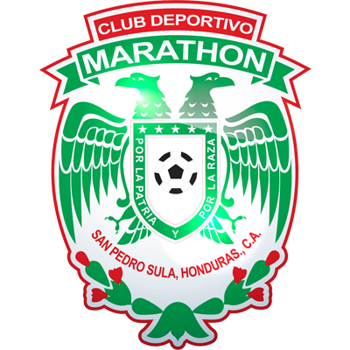 | MARATHON |  | QUARTERFINALS |  | MOTAGUA | 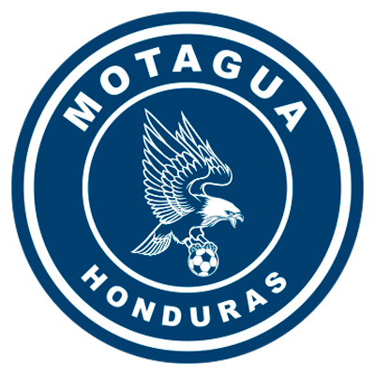

 | OCTOBER 21 |  | 10:00 PM ET |  | Metropolitan Olympic

MARATHON vs. MOTAGUA
They will meet for the first time in the Scotiabank Concacaf League.
They met in Group C of the 2002 UNCAF Interclub Cup, 2–1 victory for Motagua (José Pacini x2; Emil Martínez), Estadio Nacional de Tegucigalpa (3/NOV/2002).
Second match between Clubs of Honduras in the SCL, victory of Olimpia 2-0 vs. Motagua (Maylor Núñez and Deybi Flores), single match of Quarterfinals, National Stadium, Tegucigalpa (2/DEC/2020).
It will be the 14th game at the San Pedro Sula Metropolitan Olympic Stadium in SCL history.
Olimpia, Real España, Marathón and Motagua scored 28 goals (never has a visiting team managed to score more than one goal per game).
The home teams won 6 matches,1 away and 6 draws. Santos de Guápiles in the first leg of the Final, 2017 was the only team that achieved a triumph (0-1) vs CD Olimpia
Marathón was 5 times home in this stadium and never lost (2W-2T) where he always scored goals: 1-1 vs. Comunicaciones (Preliminary Round 2019), 1-1 vs. Antigua (R16 2019), 2-1 to Diriangén (Preliminary Round 2021) and 2-0 to Real Estelí (R16 2021).

MARATHÓN (HON)
PARTICIPATIONS: 3 (2019, 2020 and 2021). BEST RESULT: Quarterfinals 2020.
RECORD: GP-9 W-4 T-2 L-3 (GF-9 GA-9). 51.9% effectiveness.
TOP SCORERS: Edwin Solano (HON) and Mario Martínez (HON) 2, Yustin Arboleda, Allan Banegas, Frelys López, Brayan Castillo and Kervin Arriaga 1 C/U.
SCORERS IN QF: 0.
ASSISTS: Mario Martínez (HON) 2.
ASSIST IN QF: 0.
TOP SCORERS IN SCL: Edwin Solano (HON) and Yustin Arboleda (COL) 1 goal 2019, Allan Banegas (HON), Edwin Solano (HON) 1 goal in 2020, Mario Martínez (HON) 2 goals in 2021.
PLAYERS WITH MOST PRESENCES: Edwin Solano (HON) 8 games,Mathías Techera (URU), Denovan Torres (HON) and Luis Garrido (HON) 7 games.
HAT TRICKS: 0
DOUBLES: 0
YOUNGEST SCORER: Brayan Castillo (HON) with 23 years, 3 months and 18 days in the 2-0 win against Real Estelí in R16 of 2021 (23/SEP/2021).
OLDEST SCORER: Mario Martínez (HON) with 32 years, 1 month and 24 days in the 2-0 win against Real Estelí in R16 of 2021 (23/SEP/2021).
FASTEST GOAL: Edwin Solano at 3 minutes with 59 seconds in the 2-1 loss to Comunicaciones in the 2019 Preliminary Round (1/AUG/2019).
TOTAL SAVES IN SCL: (21). GOALKEEPERS: Denovan Torres (HON) 17, Luis Ortiz (HON) 4.
SAVES IN SCL 2021: (12). GOALKEEPERS: Denovan Torres (HON) 12.
PENALTY DEFINITIONS: (2). WON: 2. LOST: 0.
- Won both. 4-3 vs. Antigua (GUA) in the 2020 SCL Knockout Stage after drawing 1-1 in regulation time and Real Estelí 5-4 after drawing 2-2 on aggregate 2021's R16 scoreboard.
CD Marathon has scored goals in 7 matches, in two he failed to score and in three he did not concede goals and conceded goals in six games.
TOP PLAYERS:
- Denovan Torres (HON). He has played 7 games in the Concacaf League (making 17 saves).12 saves were in 387 minutes in 2021. Torres saved two penalties vs Antigua in the 2020 knockout stages and four vs. Real Estelí in the 2021 knockout stages. He is the goalkeeper with the most penalties saved in the history of the SCL (6)
- Mario Martinez (HON). He has taken (9) shots, scored two goals and 1 assist).
- Edwin Solano (HON). He has played in 8 of the 9 Marathon matches in SCL history. In the SCL 2021 he is the player with the most fouls received (13).
- Mathías Techera (URU). He has played 9 matches in Concacaf Club Tournaments (7 in SCL and 2 in SCCL). Together with his teammates Allans Vargas (HON) and Denovan Torres (HON) they have played in the 387 minutes in SCL 2021.
- Brayan Castillo (HON). He is the second player of the team with most shots (3) He has played 5 matches in the Concacaf League with Managua (2) and Marathón (3 and 1 scored goal vs. Real Estelí in R16).
MOTAGUA (HON)
APPEARANCES: 4 (2018, 2019, 2020 and 2021). BEST RESULT: Runner-up in 2018 and 2019.
RECORD: GP-22 W-10 T-8 L-4 (GF-30 GA-20). 57.6% effectiveness.
TOP SCORERS: Kevin López (HON) 7, Rubilio Castillo (HON) and Juan Pablo Montes (HON) 5 goals. With 3 appears Roberto Moreira Aldana (PAR).
SCORERS IN QF: Rubilio Castillo (HON) 3, Juan Pablo Montes (HON) 2.
ASSISTS IN SCL: Matías Galvaliz (ARG) 6 -leader of assists in the Concacaf League-, Kevin López (HON) 4.
QF ASSISTS: Kevin Lopez (HON) 2 and Wilmer Crisanto (HON) 1. Crisanto now plays for CD Marathon.
TOP SCORERS IN SCL: Rubilio Castillo (HON) 5 in 2018, Juan Pablo Montes (HON) 2 in 2019, Matías Galvaliz (ARG) and Kevin López (HON) 2 in 2020, and Kevin López (HON) 2 in 2021.
PLAYERS WITH MOST PRESENCES: Kevin López (HON) 22 Partidos, Walter Martínez (HON) with 21, Jonathan Rougier (ARG) 20.
HAT TRICKS: 0.
BRACES (4): Juan Pablo Montes (HON) vs. Portmore United in QF 2018, Rubilio Castillo (HON) vs. Portmore United in QF 2018, Rubilio Castillo (HON) vs. Herediano in the 2018 Final (the club's fastest in SCL with 12 minutes), and Kevin Lopez (HON) vs. Universitario in R16 2021.
YOUNGEST SCORER: Denil Maldonado (HON) with 21 years, 2 months and 26 days in the 1-2 win vs. Managua in the R16 of 2019 (21/AUG/2019).
OLDESTSCORER: Juan Pablo Montes (HON) with 33 years, 10 months and 6 days in the 3-0 win against Alianza in the Semifinals of 2019 (1/NOV/2019).
FASTEST GOAL: Juan Pablo Montes at 3 minutes with 25 seconds in the 1-1 vs. Alianza FC in the Semifinals of 2019 (24/OCT/2019).
TOTAL SAVES IN SCL: (53). GOALKEEPERS: Jonathan Rougier (ARG) 50 and Marlon Licona (HON) 3.
SAVES IN SCL 2021: (6). GOALKEEPERS: Marlon Licona (HON) 3 and Jonathan Rougier (ARG) 3.
PENALTY DEFINITIONS: (3). WON: 2. LOST: 1.
- Won in the historic series (15-14) vs. Comunicaciones in the Preliminary Round of the 2020 edition after drawing 2-2 in regulation time and 4-3 vs. Alianza in the R16 2020. They lost 4-2 to Real Estelí after equalizing 2-2 in the Repechage to SCCL 2021 at the Estadio Nacional, Tegucigalpa.
FC Motagua has scored goals in 17 matches, could not score in 5, in 9 did not concede goals and in 13 games received goals, has drawn twice (0-0) has never been able to overcome a score.
The team with the most goals scored in 17 matches and shares the record with CD Olimpia with the most games without scoring goals (5). He is one game away from matching Olimpia's record with 10 games without conding goals.
The team with the most matches tied in the Concacaf League (8).
TOP PLAYERS
- Kevin Lopez (HON). He has scored two goals in the SCL 2021 (2), runner-up in 2018 and 2019, and is the player with the most matches in the SCL (22). He has played 30 matches in international cups (7 goals between SCL and SCCL).
- Marco Tulio Vega (HON). He has played 156 minutes to date. He played with CD Marathon in the 2012–13 Concacaf Champions League.
- Wesly Decas (HON). He is the player of the team with the most shots in the 2021 Concacaf League (3) with a 33.3% efficiency. He has played in four matches in the SCL (2020 and 2021).
- Gonzalo Klusener (ARG). The Argentine striker has played in 7 international matches between SCL (5) and SCCL (2).

