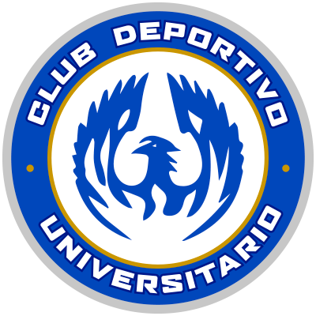 | UNIVERSITARIO |  | KNOCKOUT STAGES |  | MOTAGUA | 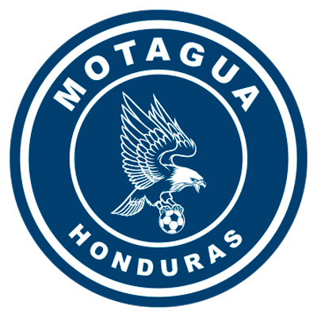

 | SEPTEMBER 23 |  | 10 PM ET |  | Agustín Muquita Sánchez Stadium

DATA

UNIVERSITARIO vs. FC MOTAGUA
They will meet for the first time in the Scotiabank Concacaf League.
8 matches have been played between clubs from Panama and Honduras in the SCL with 4 wins for the Panamanians, 2 for the Hondurans and 2 draws.
Universitario vs. Honduras Progreso (R16 2017), Plaza Amador vs. Olimpia (Semifinals 2017), Tauro vs. Real España (octavos de final 2018) and Tauro vs. Motagua (Semifinals 2018).
It will be the 7th match of SCL at the Agustín Muquita Sánchez Stadium in La Chorrera where 13 goals have been scored.
Universitario, Tauro, San Francisco and CAI played at home in this stadium.
Universitario matches in this stadium: (3-1) vs Diriangén (Oscar Villarreal x2 and Sergio Moreno; Erling Ruíz) and 1-2 vs. Herediano (Keyner Brown e/c; Keyner Brown and José Ortíz) in the 2018 Knockout and Quarter-Finals.
UNIVERSITARIO (PAN)
FOUNDATION: in 1974 it was founded as Chorrillo FC. Since June 2018 it was renamed Club Deportivo Universitario.
HEAD COACH: Gary Stempel (ENG).
PARTICIPATIONS: 3 (2017, 2018 and 2021).
BEST RESULT: Quarterfinals in 2017 and 2018.
RECORD: GP-8 W-4 T-0 L-4 (GF-10 GA-8).
TOP SCORERS: Sergio Moreno (PAN), Óscar Villarreal (PAN) with 3 goals.
ASSISTS: Josiel Núñez (PAN) with 3, Óscar Villarreal (PAN) with 2.
SAVES IN SCL: (11). GOALKEEPERS: Vladimir Vargas (PAN) 11.
DEFINITIONS BY PENALTIES: no.
THUS QUALIFIED TO THE SCL 2021: Runner-up in the Apertura 2021 Tournament of the First Division of Panama with the best aggregate record of the 2020/21 Season.
Has faced teams from Honduras (Honduras Progreso in R16, 2017), Costa Rica (Santos de Guápiles in Quarterfinals 2017) and Nicaragua (Diriangén in R16 2018).
TOP PLAYERS:
- Ivan Anderson (PAN). He was present in 3 of the 4 previous editions of the Scotiabank Concacaf League with Taurus. In 2018 he played (3) matches and scored one goal in the win (4-0) vs Walter Ferretti in the quarterfinals, in 2019 he played two matches and in 2020 one game.
- Román Torres (PAN). He is one of the most matched players in the history of the Concacaf Gold Cup (25 matches between 2007, 2009, 2011, 2013, 2015 and 2019). At club level, he played in the 2015/16 SCCL and 2018 with the Seattle Sounders.
- Joseph Cox (PAN). He recorded 4 international appearances (Concacaf Champions League 2013/14 and 2016/17) and 2 goals with Árabe Unido.
MOTAGUA (HON)
FOUNDATION: 1928.
DT: Diego Vásquez (ARG).
APPEARANCES: 4 (2018, 2019, 2020 and 2021).
BEST RESULT: Runner-up in 2018 and 2019.
RECORD: GP-20 W-9 T-7 L-4 (GF-27 GA-18).
TOP SCORERS: Rubilio Castillo (HON), Kevin López (HON), Juan Pablo Montes (HON) with 5 goals. With 3 Roberto Moreira Aldana (PAR).
ASSISTS: Matías Galvaliz (ARG) holds the record for most assists in the SCL (6), Kevin López (HON) with 4.
TOTAL SAVES IN THE SCL: (47). GOALKEEPERS: Jonathan Rougier (ARG) with 47.
PENALTY DEFINITIONS: (3). WON: 2. LOST: 1.
- They defeated (15-14) Comunicaciones in the Preliminary Round of the 2020 edition after drawing 2-2 in regulation time. This is the longest penalty shootout in the history of Concacaf club tournaments.
- Defeated Alianza (4-3) in the R16 2020.
- They lost (4-2) vs. Real Estelí after drawing 2-2 in the Repechage to qualify for the SCCL 2021 at the Estadio Nacional, Tegucigalpa.
THIS IS HOW IT QUALIFIED TO THE SCL 2021: Team with the highest record accumulated in the 2020/21 Season of the non-champion clubs in the National League of Honduras. He advanced directly to the 2021 SCL Knockout Stages.
TOP PLAYERS
- Kevin López (HON): Runner-up in 2018 (two goals and 8 matches) and 2019 (one goal in 8 matches). In 2020 he scored two goals in 4 games and has four assists in total.
- Matías Galvalíz (ARG). He is the leader in assists in the SCL (6) in 20 games. He was runner-up in 2018 and 2019.
- Jonathan Rougier(ARG) The goalkeeper has 47 saves in the SCL in the four FC Motagua participations.

