|  |  |  |  |  |  |
| --- | --- | --- | --- | --- | --- |
| ROUND OF 16 | | | | | |
|  |  |  | **23 de agosto** |  |  |
|  | **10:30 PM EDT** |
| DIRIANGÉN FC  (NCA) |  |  | **Cacique Diriangén** |  | COMUNICACIONES  (GUA) |

**Diriangén FC vs. Comunicaciones FC**

**Comunicaciones (0) Diriangén FC (1) Ramiro Peters 34´ at the** Doroteo Guamuch Flores Stadium (16-AGO, 2022).

**Ramiro Peters**: Scored the game-winning goal against Comunicaciones. It is the first win in three SCL appearances for Diriangen and the first win for a Nicaraguan team in any club competition against an opponent from Guatemala after 14 matches, 11 wins and 3 draws for Guatemalan teams.

**Peters** is also, the 4th Argentine player to debut in the SCL scoring a goal, the others were Matias Galvaliz (FC Motagua) in 2018, Lucio Barroca (Real Esteli) in 2019, Ramiro Rocca (Municipal) in 2020.

The defeat of Comunicaciones, ended five games without losing in SCL.

**Comunicaciones FC has won 4 of the last 5 away games: 0-3 vs. Once Deportivo of El Salvador (Preliminary Round 2021), 0-1 vs. Alianza of El Salvador (R16 2021), 0-1 vs. Guastatoya (SF 2021) and 1-2 vs. FC Motagua (Final 2021).**

It is the Guatemalan team with the most appearances (4), games played (18), wins (10) and goals (28) in SCL history.

**When they lost scoreless in the first leg of a knockout stage they were eliminated (lost 2-0 vs. Olimpia de Honduras in the first leg QF 2019 and tied 0-0 in the second leg).**

**Comunicaciones FC won 8 of their last 10 games. They defeated El Salvador's Once Deportivo in the Preliminary Round (0-3), El Salvador's Alianza FC in R16 (2-1 and 0-1), Saprissa in QF (2-1), Guastatoya in SF (0-1 and 2-1), Motagua in the 2021 Final (1-2 and 4-2). Lost 4-3 vs. Saprissa (QF 2021) and 0-1 vs. Diriangén FC (R16 2022).**

**They met before in the former Concacaf Champions Cup in 1971**

**Comunicaciones FC wins the series vs. Diriangén: G-2 W-2 D-0 L-0 GF-15 GA-1.**

**1**. Diriangén 0-5 Comunicaciones FC, first round match (Central American Zone), Colegio La Salle Stadium, Diriamba (22-AUG-1971).

2. Comunicaciones FC 10-1 Diriangén second leg of the First Round (Central American Zone), Doroteo Guamuch Flores stadium, Guatemala City (29-AUG-1971).

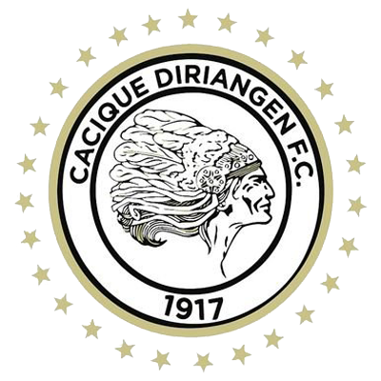 **DIRIANGÉN FC**

**SCL RECORD:** G-5 W-1 D-0 L-4 (GF-3 GA-10).

**TOP SCORERS:** Erlyng Fernando Ruíz (HON), Ramiro Peters (ARG) y Yhon Mosquera (COL) 1.

**TOP ASSISTS:** Robinson da Silva (BRA) 1.

**PLAYERS WITH MOST GAMES:** Jason Coronel (NCA) 5, Carlos Leonel Torres (ARG), Abner Acuña (NCA) 5, Luis Fernando Coronel (NCA), Erick Téllez (NCA) 4.

**SAVES:** 8. **GOALKEPERS:** Lester Acevedo (NCA) 4, Justo Llorente (NCA) 4. **CLEAN SHETTS:** 1.

**R16 RECORD:** G-3 W-1 D-0 L-2 (GF-2 GC-7).

**R16 SCORERS:** Erlyng Fernando Ruíz (HON), Ramiro Peters (ARG) 1.

**R16 ASSISTS:** Robinson da Silva (BRA) 1.

**DIRIANGÉN:** failed to advance to the round of 16 in 2018 against Universitario of Panamá (losses 0-4 and 3-1).

**RECORD IN SECOND LEG:** G-2 W-0 D-0 L-2.

**Playing at home, Diriangén FC conceded 100% of the goals in the second half (5). Defeats in 2018 (0-4 vs. Universitario of Panamá) and Preliminary Round 2021 (0-1 vs. Marathón of Honduras)**

**TOP PLAYERS**

**Robinson da Silva (BRA).** He became the first Diriangén player to assist a goal in SCL. The Brazilian has played in 7 games (100% as a starter) and has scored 1 goal (vs. Belmopán Bandits from Belize in R16 as a player for Walter Ferretti from Nicaragua).

**Ramiro Peters (ARG). He was the player with the most shots in the first leg: 3 (1 goal, 1 shot on goal and 1 deflected).**

**Luis Fernando Copete (COL).** The defender, along with his teammate Erick Téllez (NCA), were the players with the most balls recovered in the first leg vs. FC Communications (3). Between both central defenders they made 11 clearances.

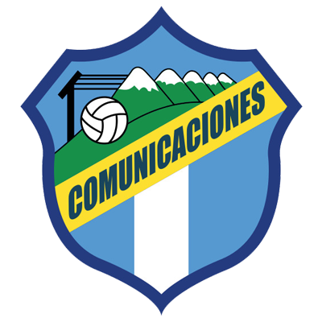**COMUNICACIONES FC**

**RECORD IN SCL:** G-18 W-10 D-5 L-3 (GF-28 GA-19).

**TOP SCORERS:** Juan Anangonó (ECU), Rafael Lezcano (CRC) 6, Junior Lacayo (HON) 4, Oscar Santis (GUA) 3.

**LEADER IN ASSISTS:** Juan Anangonó (ECU), Rafael Lezcano (CRC) 4, Maximiliano Lombardi (ARG), Oscar Santis (GUA), Stheven Robles (GUA), José Contreras (GUA), Jorge Aparicio (GUA) 2.

**PLAYERS WITH MOST MATCHES:** Stheven Robles (GUA) 17, Rodrigo Saravia (GUA) 14, Rafael Morales (GUA), Nicolás Samayoa (GUA), Andrés Lezcano (CRC) 12, José Manuel Contreras (CRC), Óscar Santis (GUA) 11.

**SAVED: 51. GOALKEEPERS:** Kevin Moscoso (GUA) 34, José Calderón (PAN) 16, Fredy Pérez (GUA) 1. CLEAN SHEETS: 5.

**RECORD IN R16: G-5 W-3 D-1 L-1 (GF-5 GA-3).**

**ROUND OF 16 SCORERS:** Júnior Lacayo (HON) 2, Andrés Lezcano (CRC), Gerardo Gordillo (GUA) and Agustín Herrera (MEX) 1.

**ASSISTS IN R16:** José Corena (COL), Juan Anangonó (ECU) and Jorge Aparicio (GUA) 1.

COMUNICACIONES EN R16: Has qualified twice, eliminated Guastatoya (2-1) on aggregate in 2019 and vs. Alianza of El Salvador (3-1) on aggregate in 2021.

**PENALTY SHOOTOUTS:**

**Lost (15-14) vs. Motagua in the Preliminary Round in 2020 after drawing 2-2 in regulation time. It is the longest penalty shootout in Concacaf club tournament history.**

**RECORD IN SECOND LEG GAMES:** G-8 W-5 D-3 L-0.

**WIN WITH MOST GOALS IN SCL:** 0-3 vs. Once Deportivo of El Salvador (José Contreras, Junior Lacayo and Andrés Lezcano), Cuscatlán stadium in San Salvador, Preliminary Round (19-AUG-2021).

**BRACES: (0). HAT-TRICKS (2):** Óscar Santis (GUA) in the first leg in QF vs. Saprissa in a 4-3 defeat (21-Oct 2021); Juan Anangono (ECU) in the final vs. Motagua of Honduras in the 4-2 victory (DEC-15, 2021).

**TOP PLAYERS**

**Kevin Lopez (HON).** He was the Comunicaciones FC player with the most shots in the first leg (3). He has played 29 games in the SCL. He is the active player with the most appearances and assists (7) in SCL history. He has scored 8 goals and was runner-up in 2018, 2019 and 2021 with FC Motagua from Honduras.

**Andres Lezcano (CRC).** He has played in 15 games in the SCL. He has scored 6 goals and 4 assists. He was part of the team that won the title in 2021 scoring (5) goals with a goal effectiveness of 71.4%

**Alexander Larin (SLV).** He had two shoots, a clearance and 47 complete passes in the first leg. Larín is the soccer player with the most victories in the history of the SCL: 14 (includes 2 games where he was on the lineup but did not play). He has played in 4 SCL editions: 2017 and 2019 with Alianza FC SLV (7 Matches) and with Comunicaciones FC (10).