FC MOTAGUA vs. COMUNICACIONES FC

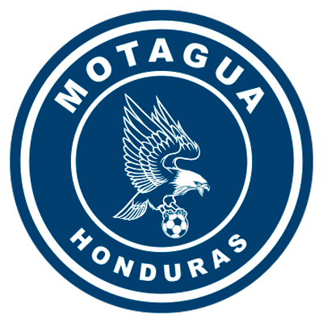 | MOTAGUA  (HON) |  | FINAL |  | COMUNICACIONES  (GUA) | 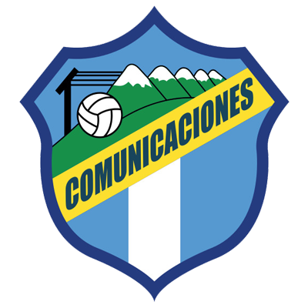

 | DECEMBER 8 |  | 7:00 PM ET |  | Estadio Nacional, Tegucigalpa.
They will meet for the second time in the Scotiabank Concacaf League and for the first time in a final of any Concacaf club tournament.
In the previous match, they drew (2-2) in the preliminary round on October 22, 2020 at the Estadio Nacional in Tegucigalpa. Andrés Lezcano and Augustín Herrera scored for Comunicaciones, Matías Galvaliz and Kevin López scored for Motagua. In the definition of penalties, Motagua won 14-15 and advanced to the knockout stages.
Of the 36 shots, 29 were scored and 7 missed. For Motagua kevin López, Juan Pablo Montes and Emilizo Izaguirre and Alejandro Galindo, Gerardo Gordillo (2) and Kevin Grijalva failed for Comunicaciones.
Motagua and Comunicaciones have faced each other five times in direct elimination series in four of them, Motagua managed to advance.
Wednesday's match will be the fifteenth between Motagua and Comunicaciones, of which, the Catracho club has four wins, 19 goals for and 12 against, one win for Comunicaciones and nine draws.
The first match between Motagua and Comunicaciones was in the former 1986 Concacaf Champions Cup in the second round of Central American Group 2.
The first leg was played in Guatemala City drawing 1-1 Oscar Girón scored for Comunicaciones and Manuel Chavarría for Motagua.
Motagua has never lost a first leg vs. Comunicaciones in direct elimination series (1-1) in 1986 (1-1) in 1991, (1-2) in 1992 and (0-0) in 1998.
Motagua managed to advance in the 1986 Concacaf Champions Cup, 1992 Central American Tournament, 1998 Central American Grand Tournament and 2020 Scotiabank Concacaf League.
The only time Comunicaciones eliminated Motagua was in the 1991 Torneo Centroamericano.
When Motagua tied in the first leg of an SCL series, they managed to win the series (3) times. Semifinals 2019 (1-1) vs. Alianza FC -SLV- (3-0 win at home). R16 2021: 2-2 vs. Universitario -PAN- (1-0 win at home). In Semifinals vs. Forge -CAN- 2-2 (0-0 at home, advanced by away goals).
So far, 16 Scotiabank Concacaf League matches have been played at the National Stadium in Tegucigalpa of which, 10 were for FC Motagua who have 6 wins and 4 draws.
It will be the 6th match between teams from Honduras and Guatemala in the history of the Scotiabank Concacaf League. Teams from Guatemala have never won in Honduras.
FC Motagua -HON- (64) and Comunicaciones FC -GUA- (75) are the clubs with the most goal situations in the 2021 Scotiabank Concacaf League. The Honduran team is the one that has the most shots (24) and the Guatemalans are the ones who have scored the most goals (15).
MOTAGUA (HON)

- The first team to play 3 Concacaf League finals (2018, 2019 and 2021).
- With a win in the first leg, Motagua will equal the record of Deportivo Deportivo Saprissa (CRC) with the most wins in the history of the SCL with 13.
- They scored goals in 77% of their matches in the SCL.
- Did not concede goals in 46.2% of matches in the SCL (12 out of 26).
- They have the best record of matches with goals scored (20) in the SCL.
- The team that played the most matches in the Concacaf League without scoring goals (6).
- It is the team with the highest number of undefeated hurdles (12) in the history of the SCL.
- It is the team with the most matches tied in the SCL (10).
- They are unbeaten playing at home in 13 matches in the SCL (7 wins and 6 draws).
- Motagua never managed to recover a match in 36 of those he has played in the history of the SCL.
- Together with Forge FC (CAN) they are the teams that tied the most without goals in the SCL (3).
- Diego Rodriguez (HON), a 26-year-old defender, was Concacaf League champion with Olimpia -HON- in 2017.
Participations in SCL: 4 (2018, 2019, 2020 and 2021).
BEST RESULT: Runner-up in 2018 and 2019
RECORD IN SCL: GP-26 W-12 T-10 L-4 (GF-36 GA-22).
TOP SCORERS IN THE HISTORY OF SCL: Kevin López (HON) 8, Rubilio Castillo (HON), Juan Pablo Montes (HON) and Roberto Moreira Aldana (PAR) with 5 goals.
GOAL SCORERS IN FINALS: Rubilio Castillo (HON) 2 vs. Herediano (CRC) in 2018 (he is the only player who has managed to score a brace in a final).
ASSIST: Matías Galvaliz (ARG) 6 -leader in the SCL-. Then, Kevin Lopez (HON) 4.
ASSISTS IN FINALS: Matías Galvaliz (ARG) and Kevin López (HON) with 1.
TOP SCORERS BY YEAR: Rubilio Castillo (HON) 5 in 2018, Juan Pablo Montes (HON) 2 in 2019, Matías Galvaliz (ARG) and Kevin López (HON) 2 in 2020; Kevin López (HON) 3 and Roberto Moreira Aldana (PAR) 2 in 2021.
PLAYERS WITH MOST MATCHES PLAYED: Kevin López (HON) 26 games,Jonathan Rougier (ARG) with 24, Roberto Moreira Aldana (PAR) and Walter Martínez (HON) and Matías Galvalíz (ARG) with 21.
HAT TRICKS: 0
BRACE (5): Juan Pablo Montes (HON) vs. Portmore United in QF 2018, Rubilio Castillo (HON) vs. Portmore United in QF 2018, Rubilio Castillo (HON) vs. Herediano in the 2018 final, Kevin López (HON) vs. Universitario in R16 of 2021 and Roberto Moreira Aldana (PAR) vs. Motagua vs. Marathón in QF 2021.
YOUNGEST SCORER: Denil Maldonado (HON) with 21 years, 2 months and 26 days in the 1-2 win vs. Managua in the R16 of 2019 (21/AUG/2019).
OLDEST SCORER: Gonzalo Klusener (ARG) with 38 years in the 2-0 win against Marathón in the first leg of QF in 2021 (21/OCT). The striker scored this goal just on the day of his 38th birthday.
FASTEST GOAL: Juan Pablo Montes at 3 minutes with 25 seconds in the 1-1 vs. Alianza FC in the Semifinals of 2019 (24/OCT/2019).
TOTAL SAVES: (65). GOALKEEPERS: Jonathan Rougier (ARG) with 62 and Marlon Licona (HON) with 3.
SAVES IN SCL 2021: (18). GOALKEEPERS: Marlon Licona (HON) with 3 and Jonathan Rougier (ARG) with 15.
PENALTY DEFINITIONS: (3). WON: 2. LOST: 1.
- Won 2 of the 3 penalty shootouts contested at SCL, 15-14 win vs. Comunicaciones in the Preliminary Round of the 2020 edition after drawing 2-2 in regulation time and 4-3 vs Alianza in R16 of 2020. They lost 4-2 vs. Real Estelí after drawing 2-2 in the Repechage for the SCCL 2021 at the Estadio Nacional.
TOP PLAYERS
- Kevin Lopez (HON). He is the club’s top scorer in the SCL (8) and matches played (26) and is the second highest scorer in history with (8) behind Johan Venegas (CRC) with 14. He was runner-up in 2018 and 2019.
- Omar Elvir (HON). He is the player with the most minutes played in the 2021 Concacaf League (575'). He is Motagua's assists leader in SCL 2021 (2). He has played 19 matches in the SCL 20.
- Matías Galvaliz (ARG). He started in all 2 of the 2018 and 2019 finals. He shares the record of assists in the history of the competition (6) with Michaell Chirinos -HON- of CD Olimpia.
- Jonathan Rougier (ARG). He has played 24 matches in SCL (finalist in 2018 and 2019). He is the goalkeeper with the most games played (24) and saves (62) since 2017. He saved a penalty kick vs. Comunicaciones in the 2020 Preliminary Round, and 2 against Alianza FC in R16 2020.
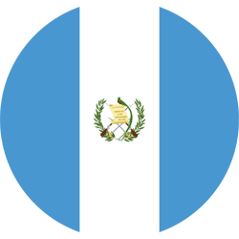 | COMUNICACIONES (GUA)

- The first team from Guatemala to play in the final of the SCL.
- The Guatemalan team with the most appearances (3), matches (15), wins (8) and goals (22) in the history of the SCL.
- Has scored goals in 80% of SCL matches. The only time they did not score was in the goalless draws vs. Guastatoya -GUA- (R16 2019) and Olimpia -HON- (QF 2019) and in the 2-0 defeat vs. Olimpia -HON- (QF 2019).
- they maintained the undefeated fence in 33.3% of the matches in the Concacaf League (5 of 15).
- Whenever they started with victory a series in the first leg in the history of the SCL, they managed to advance.
- Managed to comeback victories in 2 of the 15 matches he played in the SCL: 2-1 to CD Marathón (HON) in the Preliminary Round of 2019 and 2-1 to Guastatoya (GUA) in R16 of 2019.
- The team with the most points in the SCL 2021 (19).
- Andrés Lezcano (CRC) is the top scorer with 5.
- It is the team with the most goals scored 15.
- Alexander Robinson (CRC), a 33-year-old defender, was champion in the SCL in 2019 with Deportivo Saprissa.
PARTICIPATIONS: 3 (2019, 2020 and 2021).
BEST RESULT: Finalist in 2021.
RECORD IN THE SCL: GP-15 W-8 T-5 L-2 (GF-22 GA-15).
TOP SCORERS IN THE HISTORY OF SCL: Andrés Lezcano (CRC) 6, Júnior Lacayo (HON) and Óscar Santis (GUA) 3 EACH., Gerardo Gordillo (GUA), Juan Luis Anangonó (ECU) and Agustín Herrera (MEX) 2 each.
ASSISTS: Andrés Lezcano (CRC) 3, Maximiliano Lombardi (ARG), Jorge Aparicio (GUA), Stheven Robles (GUA), José Manuel Contreras (GUA) and Juan Luis Anangonó (ECU) 2 each.
TOP SCORERS PER SEASON: Gerardo Gordillo (GUA) 2 in 2019; Júnior Lacayo (HON), Andrés Lezcano (CRC) 5 in 2021.
PLAYERS WITH MOST MATCHES PLAYED: Stheven Robles (GUA) 14 games, Rodrigo Saravia (GUA) 12, Rafael Morales (GUA) and Nicolás Samayoa (GUA) 10 games.
HAT-TRICKS (1): Óscar Santis (GUA) first leg of SCL 2021 QF vs. Saprissa in 4-3 defeat (21/OCT).
YOUNGEST SCORER: Óscar Santis (GUA) with 22 years, 6 months and 22 days vs. Saprissa in the 4-3 defeat (21/OCT).
OLDEST SCORER: Agustín Herrera (MEX) with 35 years, 7 months and 1 day in the 2-2 vs. Motagua equality (15-14 defeat on penalties) in the 2020 Preliminary Round (23/OCT/2020).
FASTEST GOAL: Andrés Lezcano at 3 minutes with 59 seconds in the 2-1 victory against Alianza FC in R16 of 2021 (22/SEP/2021).
TOTAL SAVES IN SCL: (44). GOALKEEPERS: José Calderón (PAN) 16 and Kevin Moscoso (GUA) with 28.
SAVES IN SCL 2021: (28). GOALKEEPERS: Kevin Moscoso (GUA) 28.
PENALTY DEFINITIONS: (1). WON: 0. LOST: 1.
- Lost (15-14) vs. Motagua in the Preliminary Round in 2020 after drawing 2-2 in regulation time.
Comunicaciones adds 6 victories in its last 7 years in the SCL. Wins vs Once Deportivo -SLV- in Preliminary Round (0-3), Alianza FC -SLV- in R16 (2-1 and 0-1), Dep. Saprissa -CRC- in QF (2-1), Guastatoya -GUA- in SF (0-1 and 2-1. He only lost 4-3 vs. Deportivo Saprissa -CRC- in QF first leg).
TOP PLAYERS:
- Andrés Lezcano (CRC). He has played 9 matches with Comunicaciones in the SCL. He is the top scorer in 2021 (5). He participated in the 2 goals vs Motagua in the 2-2 draw of the Preliminary Round of SCL 2020 (1 goal and 1 assist).
- Oscar Santis (GUA). He is the only player to have scored a hat-trick at the SCL 2021 in just 22 minutes vs. Deportivo Saprissa (CRC) in the first leg's Quarter-Finals). Heis the player with the most shots in the SCL 2021 with (14).
- Juan Luis Anangonó (ECU). He scored 2 of Comunicaciones last 5 goals (vs. Dep. Saprissa in QF and vs. Guastatoya in SF). He is the field player of the cream team with the most minutes played (661').
- Kevin Moscoso (GUA). He has played 677 minutes and is the goalkeeper with the most saves (28) in the SCL 2021, has conceded 7 goals received and in 3 did not receive goals. He broke the record for the highest number of saves in the same edition, surpassing Víctor Rafael García -URU- of Alianza in 2019 with 24.

TOP 3 2021

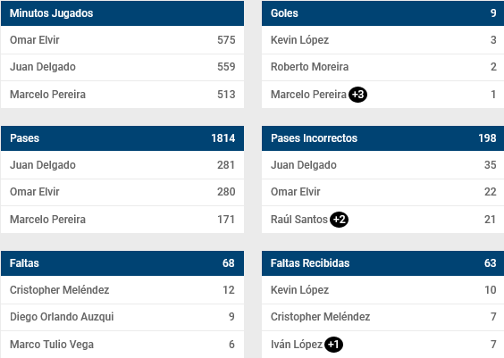
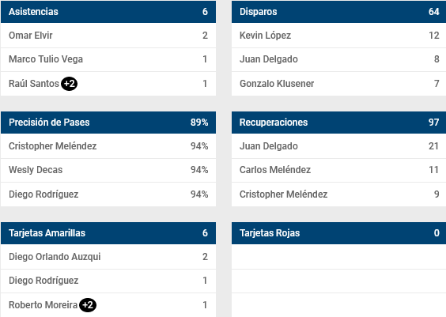

TOP 3 2021

