Round of 16
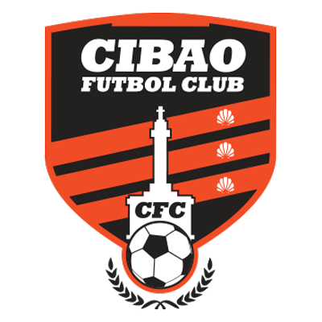 |  |  | August 17 |  | 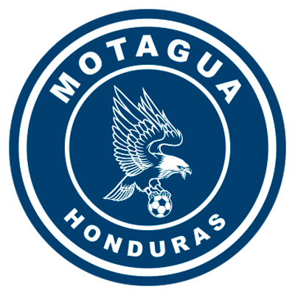
 |  |  | 8 PM ET
CIBAO FC  (DOM) |  |  | Estadio Cibao |  | FC MOTAGUA

Cibao FC vs. FC Motagua
It will be the first time that two teams from the Dominican Republic (Cibao FC) and another from Honduras (Motagua) face-off.

CIBAO FC

SCL APPEARANCES: 2 (2020, 2022)

HOW HE QUALIFIED FOR THE 2022 SCL: Runner-up of the 2022 Flow Concacaf Caribbean Club Championship.

SCL RECORD: G-1 W-0 D-0 L-1 (GF-0 GA-3).

PLAYERS WITH MOST MATCHES: Enzo Guzmán (DOM), Pablo Cofe (ARG), Roberto Peraza (CUB), Hérold Charles (HAI), Leandro Rodríguez (ARG), Mateo Zazo (DOM), Yohan Parra (DOM), Frantzety Herard (HAI), Germán Sosa (ARG), Eduardo Rotondi (ARG), Jean Carlos López (DOM), Jorge Iván Pérez (ARG), Javier Graieb (ARG), Alan Aciar (ARG), Pavel Bergaglio (ITA), Luis Díaz (DOM) 1.

SAVES: 3. GOALKEEPERS: Enzo Guzmán (DOM) 3. CLEAN SHEETS: 0.

RESULTS IN THE SCL: In his previous participation in 2020 he lost 0-3 vs. Alajuelense in the Preliminary Round in a single match goals from (Álvaro Saborío x2 and Carlos Mora), at the Alejandro Morera Soto stadium (22-Oct-2020).

Cibao FC returns to the SCL after being runner-up in the FCCCC 2022 after losing on penalties (4-3) vs. Violette AC (HAI) after drawing 0-0 in the final.

In the 2020 SCL it was eliminated in the Preliminary Round by Alajuelense, eventual champion 3-0 in a single game in Alajuela.

It is the team from the Dominican Republic with the most appearances (2) in the history of the SCL (2020 and 2021), the other is Atlético Vega Real (1).

They have 3 consecutive losses without scoring goals in the 3 matches vs. Atlético Vega Real (2L: 0-4 and 5-0) and Cibao FC (1L: 3-0).

Herold Charles (HAI) was the top scorer for CIbao FC (2) at the 2022 Flow Concacaf Caribbean Club Championship.

Jean Carlos Lopez (DOM). He played 81 minutes in the 2020 SCL. He achieved the FCCCC champion title in 2018 and the runner-up in 2022.

Lihue Prichoda (ARG). The Argentine midfielder was one of the key players for Cibao FC in the Flow Concacaf Caribbean Club Championship 2022, helping them qualify for the SCL.

FC MOTAGUA

SCL APPEARANCES: 5 (2018, 2019, 2020, 2021, 2022).
BEST FINISH: Lost the final in (2018 vs. Herediano de Costa Rica 2019 vs. Deportivo Saprissa Costa Rica and 2021 vs. Comunicaciones of Guatemala).

THIS IS HOW HE CLASSIFIED THE SCL 2022: Champion of the 2022 Torneo Apertura in Honduras.

RECORD IN SCL: G-28 W-12 D-10 L-6 (GF-39 GA-28).

TOP SCORERS: Kevin López (HON) 8, Roberto Moreira (PAR) 7, Rubilio Castillo (HON), Juan Pablo Montes (HON) 5. López now plays for Guatemalan Comunicaciones FC.

ASSIST LEADER: Kevin López (HON) 7, Matías Galvaliz (ARG) 6, Omar Elvir (HON) 4, Wilmer Crisanto (HON) 2, Marco Tulio Vega (HON) 2.

PLAYERS WITH MOST MATCHES: Kevin López (HON) 28, Jonathan Rougier (ARG) 26, Roberto Moreira (PAR) 23, Matías Galvaliz (ARG) 22, Omar Elvir (HON), Walter Martínez (HON) 21, Marcelo Pereira (HON) 20.

SAVES: 71. GOALKEEPERS: Jonathan Rougier (ARG) 67, Mario Licona (HON) 4. Clean Sheets: 12.

RECORD IN THE R16: G-7 W-4 D-3 L-0 (GF-10 GA-5).

SCORERS IN THE R16: Kevin López (HON) 3, Roberto Moreira (PAR) 2, Denil Maldonado (HON), Héctor Castellanos (HON), Matías Galvaliz (ARG), Wesly Decas (HON) 1. (in addition, he had an own goal).

ASSISTS IN THE R16: Matías Galvaliz (ARG) 3, Kevin López (HON), Omar Elvir (HON) and Denil Maldonado (HON) 1.

FC Motagua advanced four times in the round of 16: vs. Belmopan Bandits of Belize (2018), vs. Nicaraguan Managua (2019), vs. Alianza of El Salvador (2020) and vs. Universitario of Panama (2021).

SCL PENALTY SHOOT-OUT: 3. WIN: 2. LOSS: 1.

They defeated Comunicaciones FC (Guatemala) 15-14 in the Preliminary Round of the 2020 edition after drawing 2-2 in regulation time. (4-3) to Alianza (SLV) in the round of 16 in 2020. Lost (4-2) vs. Real Estelí (NCA) after drawing 2-2 in the play-off for the 2021 SCCL at the estadio nacional.

FC Motagua: Has scored goals in 22 games, did not score in 6 games, has 12 clean sheets and conceded goals in 16 games and has tied (0-0) three times.
RECORD IN FIRST LEG: G-12 W-5 D-3 L-4.

TRIUMPH WITH MOST GOALS: 3-0 vs. Alianza of El Salvador (Marco Tulio Vega, Juan Pablo Montes and Marcelo Estigarribia), 2019 Semifinal, estadio olimpico of San Pedro Sula (Oct-30).

BRACES (5): Juan Pablo Montes (HON) vs. Portmore United in the quarterfinals 2018, Rubilio Castillo (HON) vs. Portmore United in the quarterfinals 2018, Rubilio Castillo (HON) vs. Herediano in the 2018 final, Kevin López (HON) vs. Universitario of Panama in the round of 16 2021 and Roberto Moreira Aldana (PAR) vs. Marathon in quarterfinals 2021. HAT-TRICKS (0)

FC Motagua is one win away from equaling Deportivo Saprissa (CRC) as the team with the most wins in SCL history with 13.

FC Motagua is the team with the most games without conceding goals (12) with 42.9%, with the most games without scoring goals (6) and the most goals conceded with (16), the most tied games (10) and with the most games scoring goals (22).

FC Motagua is undefeated in the Round of 16 (4W-3D) 71.4% effectiveness.

Jonathan Rougier (ARG). He is the active goalkeeper with the most saves in the Concacaf League with (67) he made 21 saves in 2018, 22 in 2019, 4 in 2020 and 20 in 2021. He was runner-up in 2018, 2019, 2021 and received the Gold Glove Award in 2019 also was elected for the Best XI.

Eddie Hernandez (HON). The striker has played in 3 editions of the SCL with CD Olimpia (2019, 2020 and 2021) scoring 2 goals vs. Inter Moengotapoe from Suriname in the Round of 16 in 2021.

Roberto Moreira (PAR). He is the Paraguayan soccer player with the most goals (7 and 1 assist) in the Concacaf League. He was runner-up in 2018, 2019, 2021).
Juan Delgado (HON) was the player with the most ball recoveries in the 2021 SCL (21).

