PRELIMINARY ROUND
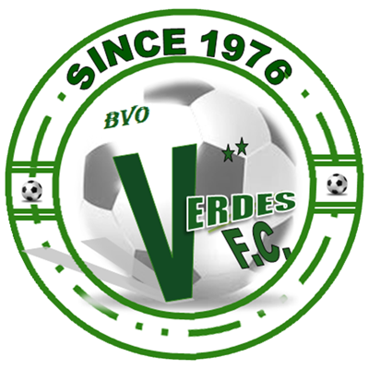 |  |  | July 27 |  | 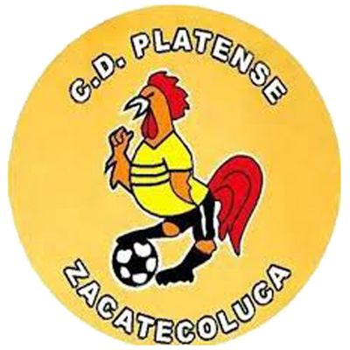
 |  |  | 10 PM ET
VERDES FC  (BLZ) |  |  | FFB Stadium |  | CD PLATENSE  (SLV)

Verdes FC vs. CD Platense
SERIES AT SCOTIABANK CONCACAF LEAGUE: They will meet for the first time and the first time between a team from Belize and another from El Salvador
Belizean teams have met in the SCL against rivals from Costa Rica, Haiti, Honduras and Nicaragua. For their part, the Salvadorans, against teams from Canada, Costa Rica, Guatemala, Honduras, Nicaragua and Panama.

VERDES FC
APPEARANCES IN SCOTIABANK CONCACAF LEAGUE: 3 (2020*, 2021, 2022).
RECORD IN SCL: G-3 W-0 D-0 L-3 (GF-1 GA-9).
TOP SCORERS IN SCL: Camilo Fajardo (COL) 1.
ASSIST LEADER IN SCL: Jesse August (BLZ) 1.
PLAYERS WITH MOST MATCHES: Camilo Fajardo (COL), Woodrow West (BLZ), Everal Trapp (BLZ), Christian Sánchez (MEX), Darrel Myvett (BLZ), Jorge Sánchez (MEX), Edwin Villeda (MEX), Norman Anderson (BLZ), Krisean López (BLZ), Junior Vargas (PAR), Jesse August (BLZ), Ronaldo Herrera (MEX), Jordy Polanco (BLZ), Wagner (BRA) 2.
SAVES: 11. GOALKEEPERS: Woodrow West (BLZ) 11. CLEAN SHEETS: 0.
BEST FINISH IN SCL: Preliminary Round 2020, 2021.
THIS IS HOW HE CLASSIFIED THE SCL 2022: Champion with the best accumulated record of the 2021/22 Season of the Belize Premier League.
SCL PRELIMINARY ROUND RECORD: G-3 W-0 D-0 L-3 (GF-1 GA-9).
Lost 0-3 vs. Arcahaie FC (HAI) - Preliminary Round 2020.
Lost 0-1 and 5-1 vs. Santos de Guápiles (CRC) - Preliminary Round 2021.
PRELIMINARY ROUND SCORERS: Camilo Fajardo (COL) 1.
PRELIMINARY ROUND ASSISTS: Jesse August (BLZ) 1.
SCL FIRST LEG MATCH RECORD: G-1 W-0 D-0 L-1 (GF-0 GA-1). *Verdes FC withdrew from the competition, awarding Arcahaie a 3–0 walkover wins into the Round of 16. The preliminary round match between Arcahaie and Verdes, originally scheduled to be played on 20 October 2020, was not played for COVID-19 cases.

➔ Camilo Fajardo (COL) scored Verdes FC's only goal in the SCL at 88 minutes in a 5-1 loss vs. Santos de Guápiles CRC in the Preliminary Round in 2021.

➔ Will tie the Belmopan Bandits' record for most Belizean teams with the most SCL appearances with (3). Verdes FC (3 Matches) and Belmopan Bandits (6 games).

➔ Krisean López (BLZ) and Junior Vargas (PAR) were the top scorers in the 2021/22 Season in Belize (7 goals) and the only players to score a hat-trick in the season.

CD PLATENSE
- APPEARANCES IN SCOTIABANK CONCACAF LEAGUE: 1 (2022 DEBUT).
- RECORD IN SCL: G-0 W-0 D-0 L-0 (GF-0 GA-0).
- THIS IS HOW HE CLASSIFIED THE SCL 2022: Runner-up of the 2021 Torneo Apertura. Non-Champion with the best accumulate record of the 2021/22 Season - from El Salvador.
➔ It is one of the 7 debutant clubs in the 2022 edition with Atlético Vega (DOM), Pacific (CAN), Cartaginés (CRC), Malacateco (GUA), Sporting San Miguelito and Alianza (PAN).

➔ It will be the 7th team from El Salvador to participate in the SCL. Alianza, CD Águila, FAS, Santa Tecla, Once Deportivo and Municipal Limeño are the others.
➔ Jhon Machado (COL), one of Platense's new hires, was one of the top scorers in the 2021/22 Season of the El Salvador First Division with 16 goals in 45 appearances playing for Jocoro SLV.

