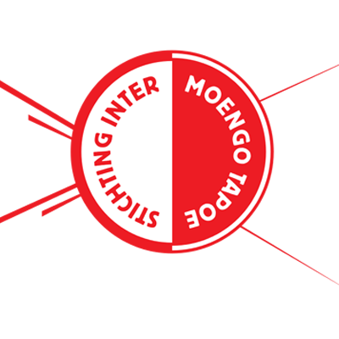 | INTER MOENGOTAPOE |  | KNOCKOUT STAGES |  | OLIMPIA | 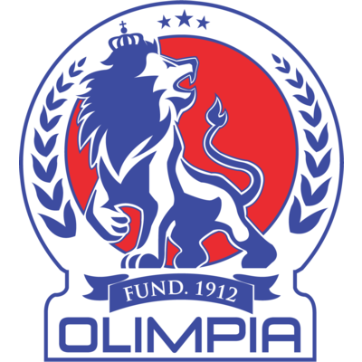

 | SEPTEMBER 21 |  | 5:45 PM ET |  | Franklin Essed Stadium

DATA

INTER MOENGOTAPOE. vs. CD OLIMPIA
First time they will face each other in SCL and in history.
It will be the first Concacaf League match at the Franklin Essed Stadion in Paramaribo, Suriname. It will be the first match between teams from Suriname and Honduras in the history of the Scotiabank Concacaf League.
Olimpia previously faced Robinhood in the final in the former 1972 Concacaf Champions Cup and won the title 1–0 on aggregate (Jorge Bran)

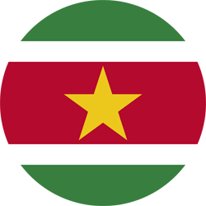 | INTER MT (ON)
FOUNDED: 1992.
COACH: Jozef Joekoe (SOUTH).
PARTICIPATIONS: 1 (2021).
BEST Result: Making his debut in the SCL. It will be the second representative team from Suriname to play in the Concacaf League. In the 2019 edition, Robinhood faced Capoise (Preliminary Round) and CAI (R16).
NATIONAL TITLES:
- SVB-Hoofdklasse: 2006/07, 2007/08, 2009/10, 2010/11, 2012/13, 2013/14, 2015/16, 2016/17 y 2018/19.
- Cup of Suriname: 2012, 2016/17 y 2018/19.
- Suriname President's Cup: 2007, 2010, 2011, 2012, 2013 y 2017.
- Guyana Cup: 2010 and 2014.
INTERNATIONAL TITLES:
- Theirb champion of the 2021 Flow CONCACAF Caribbean Club Championship.
- Runner-up of the 2018 CONCACAF Caribbean Club Shield.

International Participations:
- Participated in 10 editions of the Concacaf Caribbean Club Championship: 2004, 2007, 2009, 2011, 2012, 2014, 2015, 2016, 2017 and 2021.
- Participated in the 2018 edition of the Concacaf Caribbean Club Shield.
THIS IS HOW THEY QUALIFIED TO SCL 2021: Runner-up in the 2021 Flow Concacaf Caribbean Club Championship. He advanced directly to the 2021 SCL Knockout Stages.
TOP PLAYERS:
Miquel Darson (SOUTH). He was one of Inter MT's top scorers in 2021 Flow CONCACAF Caribbean Club Championship. He scored 3 goals in 332 minutes played (4 matches).
Rievaldo Doorson (SOUTH). He scored three goals in four matches in the 2021 Flow CONCACAF. The 21-year-old midfielder was part of Suriname's U-17 and U-20 youth teams and was a substitute in the 2019/20 Concacaf Nations League.
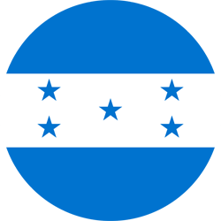 | OLIMPIA (HON)
FOUNDED: 1912.
COACH: Pedro Troglio (ARG).
PARTICIPATIONS: 4 (2017, 2019, 2020 and 2021).
BEST RESULT: Champion in the inaugural edition 2017.
RECORD: GP-17 W-10 T-3 L-4 (GF-32 GA-11).
TOP SCORERS: Roger Rojas (HON) with (5) Carlo Costly (HON) and Michaell Chirinos (HON) (3).
ASSISTS LEADERS Michaell Chirinos (HON) (6), Alexander López (3), Jorge Álvarez and Roger Rojas (2).
SAVES: (19). GOALKEEPERS: Donis Escober (HON) 19.
PENALTY DEFINITIONS: (2). WON: 1. LOST: 1.
- Victory in the 2017 Final vs. Santos de Guápiles (4-1), after drawing 1-1 on aggregate. Loss (5-4) vs. Alajuelense after drawing 0-0 in the single match in the 2020 semifinals.
THUS, QUALIFIED TO THE SCL 2021: Champion of the Apertura 2020 and Clausura 2021 tournaments of the Honduran National League. They advanced directly to R16 of SCL 2021.
TOP PLAYERS :
- Michaell Chirinos (HON). He has scored (4) goals in (6) sccl.
- Jerry Bengtson (HON). The veteran striker has 24 appearances in Concacaf club tournaments. He played 8 SCL matches in 2019 and 2020 where he scored 2 goals (vs. Forge in 2019, and Managua in 2020, in the Knockout Stage).

