Round of 16
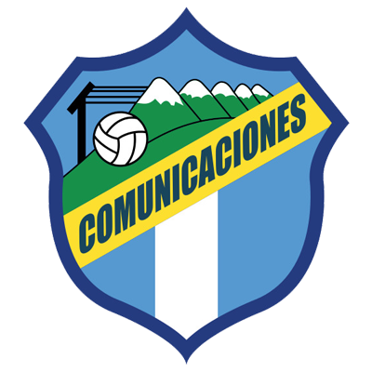 |  |  | August 16 |  | 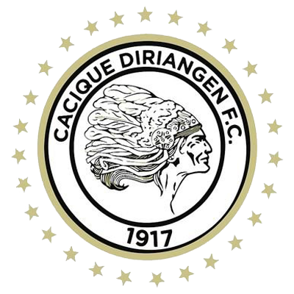
 |  |  | 8 PM EDT
COMUNICACIONES  (GUA) |  |  | Doroteo Guamuch Flores |  | DIRIANGÉN FC  (NCA)

Comunicaciones FC vs. Diriangén FC

SERIES IN SCL: They will meet for the first time in the Scotiabank Concacaf League, but they met in the late Concacaf club tournament in 1971.

1. Diriangén 0-5 Comunicaciones FC match of the First Round (Central American Zone) at the Colegio La Salle stadium, Diriamba (22-AUG-1971).

2. Comunicaciones FC 10-1 Diriangén second leg of the First Round (Central American Zone) at the Doroteo Guamuch Flores stadium, Guatemala City (29-AUG-1971).

COMUNICACIONES FC

SCL APPEARANCES: 4 (2019, 2020, 2021, 2022).
BEST FINISH: Champion 2021.
HOW DO THEY QUALIFY FOR THE SCL 2022: Champion of the 2022 in Guatemala´s Torneo Apertura.
RECORD IN SCL: G-17 W-10 D-5 L-2 (GF-28 GA-18).
TOP SCORERS: Juan Anangonó (ECU), Rafael Lezcano (CRC) 6, Junior Lacayo (HON) 4, Oscar Santis (GUA) 3.
ASSIST LEADER: Juan Anangonó (ECU), Rafael Lezcano (CRC) 4, Maximiliano Lombardi (ARG), Oscar Santis (GUA), Stheven Robles (GUA), José Contreras (GUA), Jorge Aparicio (GUA) 2.
PLAYERS WITH THE MOST MATCHES: Stheven Robles (GUA) 16, Rodrigo Saravia (GUA) 14, Rafael Morales (GUA), Nicolás Samayoa (GUA) 12, Andrés Lezcano (CRC) 11, Juan Anangonó (ECU), José Manuel Contreras (CRC), Óscar Santis (GUA), Junior Lacayo (HON) 10.
SAVES: 50. GOALKEEPERS: Kevin Moscoso (GUA) 34, José Calderón (PAN) 16. UNDEFEATED HURDLES: 5.
RECORD IN THE R16: G-4 W-3 D-1 L-0 (GF-5 GA-2).
SCORERS IN THE R16: Júnior Lacayo (HON) 2, Andrés Lezcano (CRC), Gerardo Gordillo (GUA) and Agustín Herrera (MEX) 1.
ASSISTS IN THE R16: José Corena (COL), Juan Anangonó (ECU) and Jorge Aparicio (GUA) 1.
COMUNICACIONES IN THE ROUND OF 16: Beat Guastatoya GUA (2-1 on aggregate in 2019) and Alianza SLV (3-1 on aggregate in 2021).
SCL SHOOT OUTS DEFINITIONS: 1. WIN: 0. LOST: 1.
Lost (15-14) in the historic series vs. FC Motagua of Honduras in the Preliminary Round in 2020 after drawing 2-2 in regulation time.
COMUNICACIONES: he has scored goals in 14 games, only in three games he did not score, in 12 he conceded goals and five clean sheets. He has tied twice (0-0) vs. Guastatoya from Guatemala in the round of 16 in 2019 and CD Olimpia from Honduras in the quarterfinals in 2019).
RECORD IN FIRST LEG GAMES: G-8 W-5 D-1 L-2.
WIN WITH MOST GOALS IN SCL: 0-3 vs. Once Deportivo from El Salvador (José Contreras, Junior Lacayo and Andrés Lezcano) at the Cuscatlán stadium in San Salvador for the 2021 Preliminary Round (19-AUG-2021).
HAT-TRICKS (2): Óscar Santis (GUA) scored a hat-trick in the first leg in the quarterfinals in 2021 vs. Saprissa in defeat 4-3 (21-Oct); Juan Anangonó (ECU) scored three goals in the 2021 SCL Final vs. Motagua of Honduras in the 4-2 victory (15-Dec).
Comunicaciones FC won the SCL for the first time in 2021 after defeating FC Motagua of Honduras in the final with an aggregate score of 6-3.

In 2021 it was the team with the most points in the SCL (25) with 7 wins in its last 8 games and the team with the most goals scored with (21) assists (16) and shots (97) and it is so far the only team to win both games in the final.

It is the Guatemalan club with the most appearances (4), matches (17), victories (10) and goals (28) in SCL history.

He scored goals in 82.3% of the games in the Concacaf League, kept the clean sheet in 29.4% of the games (5 of 16).

So far he has 8 wins in his last 9 games, Results: Defeated Once Deportivo SLV in Preliminary Round (0-3), Alianza FC SLV in R16 (2-1 and 0-1), Deportivo Saprissa CRC in QF (2 -1), Guastatoya GUA in SF (0-1 and 2-1), Motagua HON in the 2021 Final (1-2 and 4-2). He only lost 4-3 vs. Deportivo Saprissa -CRC- in the first leg of the quarterfinals in 2021.

Kevin López (HON) is the player with the most appearances (28) and assists (7) in the history of the Scotiabank Concacaf League. He was runner-up as a player for FC Motagua in 2018, 2019 and 2021 where he was also the top scorer (8). He had 2 assists in the final vs Comunicaciones FC in the 2021 final.

Kevin Moscoso (GUA) He set a record for saves in the same edition of the SCL with (34) which earned him the Gold Glove Award and being chosen in the Best XI of the Tournament.

Andres Lezcano (CRC). He has scored 6 goals and 4 assists in 13 SCL games. He was a key player to win the title in 2021 with a goal effectiveness of 71.4% (scoring 5 goals).

Luis Landin (MEX). The veteran striker has scored 3 goals and 1 assist in 6 games as a player for Guatemala's Guastatoya in the last 2 editions of the SCL in 2020 and 2021).

DIRIANGÉN FC
SCL APPEARANCES: 3 (2018, 2021, 2022).
BEST RESULT: Round of 16 in 2018.
THIS IS HOW HE CLASSIFIED TO THE 2022 SCL: Champion of the 2021 Nicaragua´s Torneo Apertura.
RECORD IN SCL: G-4 W-0 D-0 L-4 (GF-2 GA-10).
TOP SCORERS: Erlyng Fernando Ruíz (HON) 1, Yhon Mosquera (COL) 1.
PLAYERS WITH MOST MATCHES: Jason Coronel (NCA), Carlos Torres (ARG), Abner Acuña (NCA) 4, Luis Fernando Coronel (NCA), Erick Téllez (NCA), Pedrinho (BRA) 3.
SAVED: 6. GOALKEEPERS: Lester Acevedo (NCA) 4, Justo Llorente (NCA) 2. CLEAN SHEETS: 0.
RECORD IN THE R16: G-2 W-0 D-0 L-2 (GF-1 GA-7).
R16 SCORERS: Erlyng Fernando Ruíz (HON) 1.
Diriangén FC was eliminated in the round of 16 by Universitario PAN (loses 0-4 and 3-1) in 2018
DEFINITIONS BY PENALTIES SCL: 0.
DIRIANGÉN FC: He has scored goals in two games, has never stopped conceding goals and in two games he did not score goals. They have not won or drawn in the previous 4 games in 2018 and 2021 (100% losses).
SCL FIRST LEG MATCH RECORD: G-2 W-0 D-0 L-2.
He played for the first time in the round of 16 in 2018 (he was eliminated by Universitario de Panamá) and in the Preliminary Round in 2021 by CD Marathón de Honduras).
They lost all 4 of their matches in 2018 (round of 16) and in the preliminary round in 2021.
Robinson Luis (BRA). He played in the SCL in 2017 scoring one goal vs. Belmopán Bandits in the round of 16 and had 4 appearances with Walter Ferretti from Nicaragua and in 2021 with Diriangén 2 matches.
Luis Colonel (NCA). He played with Diriangén FC in the SCL 2018 (2 Caps) and 2021 (1). The striker scored 10 goals in 37 appearances in the 2021/22 season of the Nicaraguan League.
Yohn Mosquera (COL). He scored 1 goal in 2 games with Diriangén in the 2021 SCL. Also, he played in 2020 with Real Estelí NCA (3 games).

