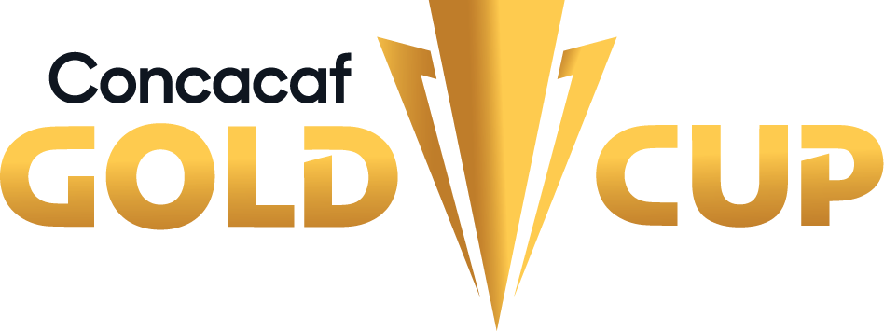

MEXICO - HONDURAS
Mexico leads the all-time series in regulation time GP-42 W-26 D-9 L-7 (GF-77 A-29).
SERIES IN GOLD CUP: Mexico leads the all-time series in regulation time GP-7 W-4 D-2 L-1 (Gf-10 A-3).
From the 7 matches in the Gold Cup, four were in the group stage. The matches between Mexico and Honduras are one of the most frequently played in the history of the Gold Cup, alongside PAN vs. USA (11) and CAN vs. CRC (9). Other notable match-ups include USA vs. JAM, GUA vs. MEX, JAM vs. MEX, CRC vs. MEX, CRC vs. USA, and MEX vs. USA.
HEAD-TO-HEAD IN GOLD CUP:
Mexico 1-1 Honduras (Carlos Hermosillo; Marco Zelaya), Grupo A - 1991, Los Angeles Memorial Coliseum, Los Ángeles (3-JUL-1991).
Mexico 2-0 Honduras (Cuauhtémoc Blanco x2), Grupo B - 1998, Network Associates Coliseum Oakland (7-FEB-1998).
Mexico 0-0 Honduras, Grupo A - 2003, Estadio Azteca, Ciudad de México (17-JUL-2003).
Mexico 1-2 Honduras (Carlo Costly x2; Cuauhtémoc Blanco), Grupo C - 2007, Giants Stadium East Rutherford (10-JUN-2007).
Mexico 2-0 Honduras -Tiempo Extra- (Aldo de Nigris y Javier Hernández), semifinales - 2011, Reliant Stadium, Houston (22-JUN-2011).
Mexico 1-0 Honduras (Rodolfo Pizarro), cuartos de final - 2017, University of Phoenix Stadium, Glendale, -State Farm Stadium- (20-JUL-2017).
Mexico 3-0 Honduras (Rogelio Funes Mori, Jonathan dos Santos y Orbelín Pineda), cuartos de final - 2021, State Farm Stadium, Glendale (24-JUL-2021).
LEADING SCORERS IN MEX vs. HON GOLD CUP MATCHES:
Mexico: Cuauhtémoc Blanco (3). Honduras: Carlo Costly (2), Marco Zelaya (1).
PLAYERS WITH THE MOST APPEARANCES IN MEX vs. HON GOLD CUP MATCHES:
Mexico: Pavel Pardo (3 matches). Honduras: Oscar Boniek García (4 matches), Maynor Figueroa (3 games).
MANAGERS IN THE MEX vs. HON SERIES:
Mexico: Manuel Lapuente (MEX) 2 (1991, 1998).
Honduras: Flavio Ortega (BRA) 1 (1991), Miguel Company (PER) 1 (1998), Edwin Pavón (HON) 1 (2003), Reinaldo Rueda (COL) (2007), Luis Fernando Suárez (COL) 1 (2011), Jorge Luis Pinto (COL) 1 (2017), Arnold Cruz (HON) 1 (2021).
MEMORABLE MATCHES IN MEX vs. HON:
Mexico 8-2 Honduras. The first-ever match between the two teams in 1935 at the Central American and Caribbean Games in El Salvador. Hilario López and Julio Lores scored 3 goals each.
Honduras 2-1 Mexico (Carlos Pavón and Eduardo Bennett; Ramón Ramírez for Mexico) in San Pedro Sula, Third Round of the Concacaf qualifiers for the FIFA World Cup France 1998, at the General Francisco Morazán Stadium (21-SEP-1996). It was Honduras' first victory against Mexico, 61 years after their first meeting.
Mexico 1-2 Honduras (Oribe Peralta for Mexico; Jerry Bengtson and Carlo Costly) in the "Aztecazo". It was Honduras' only victory on Mexican soil in 2013, during the Concacaf qualifiers for the FIFA World Cup Brazil 2014, at the Azteca Stadium.
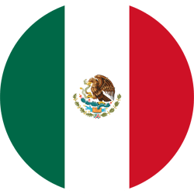MEXICO (MEX)
Mexico has participated in 17 editions of the Concacaf Gold Cup: 1991, 1993, 1996, 1998, 2000, 2002, 2003, 2005, 2007, 2009, 2011, 2013, 2015, 2017, 2019, 2021, 2023.
Mexico has been champion 8 times in 1993 (vs. USA), 1996 (vs. BRA), 1998 (vs. USA), 2003 (vs. BRA), 2009 (vs. USA), 2011 (vs. USA), 2015 (vs. JAM), and 2019 (vs. USA), and runner-up in 2007 and 2021.
In the Gold Cup, Mexico has played 10 finals, and in six of those finals, they did not concede any goals. In 79 matches in the Gold Cup, they did not concede any goals and they are the team with the most goals scored in the history of the tournament with 180 goals.
FIRST MATCH OF MEXICO IN EACH EDITION: They only drew in one of their 16 opening matches in the Gold Cup (0-0 against Trinidad in 2021). The rest were 13 wins and 2 losses.
Team Record: GP-79 W-57 D-12 L-10 (GF-180 GA-47).
Top scorers in Gold Cup: Andrés Guardado (12), Luis Roberto Alves (12), Jared Borgetti (7), Javier Hernández (7), Raúl Jiménez (7), Giovani dos Santos (6).
Top scorers in Gold Cup 2021: Rogelio Funes Mori (3), Orbelín Pineda (3) Luis Rodríguez, Héctor Herrera y Jonathan dos Santos (1).
Players with the most appearances: Andrés Guardado (24), Guillermo Ochoa (19), Gerardo Torrado (19). Andrés Guardado is the top scorer for Mexico in finals with (3) goals.
Coaches with the most games in the Gold Cup: Gerardo Martino (12), Manuel Lapuente (12), José Manuel De La Torre (11).
Their best performance was: Winner in Gold Cup 1993, 1996, 1998, 2003, 2009, 2011, 2015, 2019.
Players used in the Gold Cup: 200.
Saves (Editions 2015/2017/2019/2021): 50. Top Goalkeepers: Guillermo Ochoa (21), Jesús Corona (17), Alfredo Talavera (11).
Penalty Shootout Decisions: 3. WIN: 2 (5-3 vs CRC in SF 2009, 5-4 vs CRC in QF 2019). LOST: 1 (2-4 vs South Korea in QF 2002).
Best Result: 9-0 vs. Martinica (Luis Alves x7, Ramón Ramírez y Juan Hernández), Group B - 1993, Estadio Azteca (11-JUL). This is the victory with the largest goal difference in the history of the tournament.
Qualification to the 2023 Gold Cup: 1° Place (Group A - League A).
Record in CNL: GP-10 W-6 D-3 L-1 (GS-23 GA-9).
Top scorers in CNL: José Juan Macías (3), Uriel Antuna (2), Raúl Jiménez (2), Hirving Lozano (2).
Record in CNL 2022/23: GP-4 W-2 D-2 L-0 (GS-8 GA-3).
Top scorers in CNL 2022/23 (League A): Hirving Lozano, Orbelín Pineda, Johan Vásquez, Luis Romo, Erick Sánchez, Henry Martín, Israel Reyes (1).
Assists leader in CNL 2022/23 (League A): Carlos Rodríguez, Henry Martín, Luis Chávez (1).
Saves CNL 2022/23: (8). Carlos Acevedo (5), Guillermo Ochoa (3).

TOP PLAYERS
Raúl Jiménez has scored 7 goals in 11 matches in the Concacaf Gold Cup between 2013 and 2019. In the 2019 edition, he played 594 minutes and scored 5 goals with 2 assists. He was also the winner of the Golden Ball award and included in the Tournament's Best XI. He was the leader in shots with 37 and shots on target with 18.
Orbelín Pineda was part of the team that won the 2019 Gold Cup, scoring one goal in 5 matches. In the 2021 edition, he scored 3 goals (2 headers and 1 penalty). Pineda has scored 4 goals in 12 Gold Cup matches, distributed as follows: 2017 (1 goal in 5 matches), 2019 (1 match), and 2021 (3 goals in 6 matches).
Edson Álvarez was the leader in passes (401) in the 2021 edition and had the most successful passes (380). Álvarez has played 16 matches in the Gold Cup: 2017 (1 goal in 5 matches), 2019 (5 matches), and 2021 (6 matches). He won the title in 2019 and was the runner-up in 2021. He was selected in the Best XI in the 2021 edition.
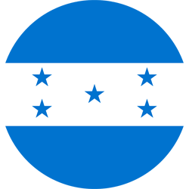HONDURAS (HON)
Honduras have participated in 16 editions of the Concacaf Gold Cup: 1991, 1993, 1996, 1998, 2000, 2003, 2005, 2007, 2009, 2011, 2013, 2015, 2017, 2019, 2021, 2023 - HON was only absent in the 2002 edition.
In their debut in the 1991 Gold Cup, Honduras defeated Canada 4-2, with Eduardo Bennett scoring the first goal in the history of the Gold Cup.
Honduras achieved their best performance in the history of the Gold Cup in 1991, finishing as runners-up after losing in a penalty shootout (4-3). Additionally, they have finished in third place four times (2005, 2009, 2011, and 2013).
In the first match of each edition in the Gold Cup, Honduras has a record of 6 wins, 2 draws, and 7 losses.
Team Record: GP-55 W-22 D-8 L-25 (GS-83 GA-71).
Top scorers in Gold Cup: Carlos Pavón (9), Carlo Costly (8), Eduardo Bennett (7), Jerry Bengtson (4).
Top scorers in Gold Cup 2021: Romell Quioto (3), Edwin Solano, Jerry Bengtson, Alexander López y Johnny Leverón (1).
Players with the most appearances: Maynor Figueroa (23), Óscar Boniek García (22), Osman Chávez (15), Carlo Costly (14), Alex López (14), Bryan Acosta (12), Samuel Caballero (12), Donis Escober (12).
Coaches with the most games in the Gold Cup: Luis Fernando Suárez COL (10), Reinaldo Rueda COL (9).
Their best performance was: Runner-up in Gold Cup 1991.
Players used in the Gold Cup: 163.
Saves (Editions 2015/2017/2019/2021): 43. Goalkeepers: Luis López (36), Donis Escober (7).
Penalty Shootout: 2. WIN: 1 (4-2 vs CRC in QF 2011). LOST: 1 (4-3 vs USA in Final 1991).
Best Result: 7-1 vs. Granada (Jerry Bengtson x2, Carlo Costly x3, Walter Martínez y Alfredo Mejía; Clive Murray), Group B - 2011, FIU Stadium, University Park (10-JUN).
Qualification to the 2023 Gold Cup: 2° Place (Group C - League A).
Record in CNL: GP-10 W-5 D-2 L-3 (GF-15 GA-11).
Top scorers in CNL: Alberth Elis (3), Brayan Moya (2), Kervin Arriaga (1), Kevin López (1), Douglas Martínez (1), José Pinto (1), Edwin Rodríguez (1), Jorge Benguché (1), Jonathan Rubio Toro (1), Romell Quioto (1), Juan Ramón Mejía, (1).
Record in CNL 2022/23: GP-4 W-2 D-0 L-2 (GS-5 GA-7).
Top scorers in CNL 2022/23 (League A): Kervin Arriaga (1), Kevin López (1), José Pinto (1), Jorge Benguché (1), Romell Quioto (1).
Assists leader in CNL 2022/23 (League A): Edwin Solano (1), Joseph Rosales (1), Romell Quioto (1).
Saves CNL 2022/23: (8). Luis López (6) y Harold Fonseca (2).
TOP PLAYERS
Alberth Elis: In 2021, he was part of the team that won third place in the inaugural edition of the Concacaf Nations League (scored 3 goals in 5 appearances). In the Concacaf qualifiers for the FIFA World Cup Qatar 2022, he scored 1 goal in 8 appearances.
Alexander López: He scored 1 goal and provided 2 assists and was the leader in shots for Honduras with 8 in the 2021 Gold Cup. López has played in 4 editions of the Gold Cup: 2013 (5 matches), 2017 (3 matches), 2019 (2 matches), and 2021 (1 goal in 4 matches).

